COVER MAP - The Public Land Ownership map used on the cover of this report was prepared by the Minnesota Department of Natural Resources in 1978. No new map was prepared for this inventory, but the revised data is stored in a computerized system which allows mapping in many formats.

Note: the cover of the original printed report is in color.

MINNESOTA PUBLIC LANDS, 1983

Prepared by

LAND MANAGEMENT INFORMATION CENTER
MINNESOTA STATE PLANNING AGENCY
65 METRO SQUARE BUILDING
ST. PAUL, MN 55101
(612) 296-1211

In cooperation with

LAND BUREAU
MINNESOTA DEPARTMENT OF NATURAL RESOURCES
CENTENNIAL OFFICE BUILDING
ST. PAUL, MN 55155
(612) 296-4097

Funding Assistance Provided by

LEGISLATIVE COMMISSION ON MINNESOTA RESOURCES
B-46 STATE CAPITOL BUILDING
ST. PAUL, MN 55101
(612) 296-2406

NOVEMBER, 1983

(Note: updated contact information is available at:
www.lmic.state.mn.us
www.dnr.state.mn.us
www.commissions.leg.state.mn.us/lcmr/lcmr.htm)
CONTENTS

INTRODUCTION 1
SUMMARY TABLE 5

SUMMARY MAPS AND CHARTS 6-8

SECTION 1 - FEDERAL LAND 9

FOREST SERVICE 10-11
FISH AND WILDLIFE SERVICE 12-13
NATIONAL PARK SERVICE 14-15
BUREAU OF LAND MANAGEMENT 16-17
ARMY CORPS OF ENGINEERS 18-19
OTHER FEDERAL LAND 20-21

SECTION 2 - STATE LAND 22

DEPARTMENT OF NATURAL RESOURCES 23
FORESTRY 24-25
WILDLIFE MANAGEMENT AREAS 26-27
PARKS AND RECREATION 28-29
OTHER DEPARTMENT OF NATURAL RESOURCES LAND 30-31
DEPARTMENT OF TRANSPORTATION 32-33
MILITARY AFFAIRS 34-35
UNIVERSITY OF MINNESOTA . 36-37
OTHER STATE LAND 38-39

SECTION 3 - TAX-FORFEITED LAND 40

TAX-FORFEITED LAND 40-41

SECTION 4 - METROPOLITAN COMMISSION LAND 42

METROPOLITAN AIRPORTS COMMISSION 42-43
METROPOLITAN TRANSIT COMMISSION . 42-43
METROPOLITAN WASTE CONTROL COMMISSION 42-43

REFERENCES 45

TABLES 47

TABLE 1 - FEDERAL LAND OWNERSHIP, 1960 47
TABLE 2 - FEDERAL LAND OWNERSHIP, 1970 48
TABLE 3 - FEDERAL LAND OWNERSHIP, 1981 49
TABLE 4 - FEDERAL LAND BY COUNTY, 1983 50-51
TABLE 5 - DEPARTMENT OF NATURAL RESOURCES LAND
BY COUNTY, 1983 52-53
TABLE 6 - NON-DNR STATE LAND BY COUNTY, 1983 54-55
TABLE 7 - TAX-FORFEITED AND METROPOLITAN
COMMISSIONS LAND BY COUNTY, 1983 56-57
TABLE 8 - PERCENT OF PUBLIC LAND
BY COUNTY, 1983 58-59

INTRODUCTION

Over the last three decades, there seems to have been a renewed interest in public land. Every five to ten years an inventory was prepared as a one-time project. Notable inventory efforts of the past have been cited in this report. During the 1981 State Legislative session, money was appropriated to the Department of Energy, Planning and Development (DEPD) to begin an on-going inventory process of summary land records. The work effort was coordinated by the Land Management Information Center (LMIC). This appropriation from the Legislative Commission on Minnesota Resources (LCMR) was to improve the organization and accessibility of summary public land record information in Minnesota.

To develop this process, LMIC expanded and enhanced the computerized public land summary records in the Minnesota Land Management Information System (MLMIS). Processes were developed to continually maintain these records. Other project work items of importance in this project included the automation of related land records in the Department of Natural Resources (DNR) and the microfilming of valuable, historic land records of the State coordinated by the Minnesota State Historical Society (MHS). The final status report of this biennial project can be obtained from either the LCMR or the LMIC offices.

During the 1981-83 biennium, LMIC attempted to gather summary land record information for all federal land managing agencies (except one noted below), all non-DNR state agencies (except one noted below) and several regional commissions in the Twin Cities metropolitan area. The Land Bureau of the Minnesota Department of Natural Resources coordinated all records for DNR managed lands. It is hoped that future editions of this report can be expanded to include those omitted agencies and those other public lands managed by counties and cities.

Every federal land managing agency, except the Bureau of Indian Affairs, was included in this inventory by LMIC. The federal agencies inventoried included:

DEPARTMENT OF AGRICULTURE
- Forest Service
- Science/Education Administration
DEFENSE DEPARTMENT
- Department of the Air Force
- Department of the Army
- Department of the Navy
- Corps of Engineers
DEPARTMENT OF ENERGY
- Western Area Power Administration
ENVIRONMENTAL PROTECTION AGENCY
GENERAL SERVICES ADMINISTRATION
DEPARTMENT OF HEALTH, EDUCATION AND WELFARE
- Health Services Administration
- Social Security Administration

1
DEPARTMENT OF INTERIOR
- Fish and Wildlife Service
- Geological Survey
- Bureau of Land Management
- Bureau of Mines
- National Park Service
DEPARTMENT OF JUSTICE
- Immigration and Naturalization Service
- Bureau of Prisons
DEPARTMENT OF LABOR
- Employment & Training Administration
POSTAL SERVICE
DEPARTMENT OF TRANSPORTATION
- Coast Guard
- Federal Aviation Administration
TREASURY DEPARTMENT
- Bureau of Customs
VETERANS ADMINISTRATION

An attempt was made to inventory all state land, except for Department of Transportation's highway right-of-way. Data was obtained for all agencies except DOT right-of-way and the two DOT sections indicated on the list below. Several major regional agencies in the Twin Cities metropolitan area were also included in this effort. The agencies inventoried included:

DEPARTMENT OF ADMINISTRATION
DEPARTMENT OF AGRICULTURE
DEPARTMENT OF CORRECTIONS
DEPARTMENT OF ECONOMIC SECURITY
DEPARTMENT OF EDUCATION
DEPARTMENT OF MILITARY AFFAIRS
DEPARTMENT OF PUBLIC WELFARE
DEPARTMENT OF TRANSPORTATION
- Aeronautics
- Gravel Pits
- Headquarters, Maintenance and Storage*
- Rest Areas*
- Right of Way*
DEPARTMENT OF VETERANS AFFAIRS
IRON RANGE RESOURCES AND REHABILITATION
METROPOLITAN AIRPORTS COMMISSION
METROPOLITAN TRANSIT COMMISSION
METROPOLITAN WASTE CONTROL COMMISSION
MINNESOTA AGRICULTURAL SOCIETY (STATE FAIR)
MINNESOTA HISTORICAL SOCIETY
MINNESOTA Z00
STATE COMMUNITY COLLEGES
STATE UNIVERSITIES
UNIVERSITY OF MINNESOTA

*Only State total available at this time.

2
The Land Bureau of the Department of Natural Resources enhanced and expanded its on-going land inventory system which includes lands administered under the following DNR programs:

CANOE AND BOATING RIVERS
DNR ADMINISTRATION
FISHERIES
FORESTRY
LAW ENFORCEMENT
PARKS AND RECREATION
PUBLIC ACCESS
SCIENTIFIC AND NATURAL AREAS
TRAILS
WATERS OR MINERALS
WAYSIDES
WILD AND SCENIC RIVERS
WILDLIFE

This DNR inventory system also includes state-owned tax-forfeited lands which are under the following management:

COUNTY FORESTS (tax-forfeited) LAND
OTHER COUNTY (tax-forfeited) LAND

While this current inventory effort is probably the most accurate and complete of any inventory in the State's history, the resulting statistics represent only an "educated guess" estimate of actual public ownership. This results from several causes, not the least of which is the lack of a central focus for land statistics. As stated in a 1983 "Evaluation of State Land Acquisition and Disposal" report by the Office of the Legislative Auditor, "No state agency maintains a comprehensive inventory of all state owned land." As we discovered during the course of this inventory, one federal agency does attempt to maintain an inventory of federal lands, but it has not published up-dated data since 1979 and most current agency records vary in some degree with this national summary.

Today the accuracy of public land records varies greatly from agency to agency and county to county. It should be noted that most major land managing agencies have, by necessity, fairly good land records. However, agencies which manage public "facilities" on public land, rather than managing public land directly, have records ranging from good to nearly non-existent. Until the relatively recent passage of state and federal laws requiring "payment-in-lieu-of-taxes" to local governments for certain classes of public lands, there was little incentive for governments to maintain accurate and costly records.

In reviewing past inventories of Minnesota's public lands, we found differences in the comprehensiveness and definition. This was further complicated by the fact that agencies and programs often change name and organizational location. In addition to all of these problems, irregularities on the original Public Land

3
Survey system can greatly complicate agency acreage totals. Given all of these potential sources of data errors, recording of public land records can be a difficult task.

In 1977, a "Minnesota Public Lands Impact Study" was prepared for the Legislative Commission on Minnesota Resources (LCMR). It addressed many public land issues including public land records management. One recommendation of that study stated:

"While property record integration is probably more efficient from a systems point of view, it is likely that the integration of records would reduce the effectiveness of the agencies using the information because direct access would be removed. Rather than integrating the existing systems into one massive data base, they should be made directly compatible with one another. Any central system should be an overview system with key information bits and format determined by and utilized by all government jurisdictions compiling individual record files."

It is hoped that this published report and the detailed statistical reports which can be generated from the computerized inventory enhanced by this project, will serve as a beginning for such a system. It is probably not worth the phenomenally high cost for the State to develop a 100% accurate public land inventory. However, a standardized summary system can be continually maintained with the cooperation of land record managers at all levels of government.

It is likely that some data errors are contained in a data system of this size. Should you find data problems in this report or any of the statistics that might be generated, please write to the Land Management Information Center. Only through continual review and enhancement can this system be maintained with a high level of accuracy.

NOTE - The following areas, published by the U.S. Department of the Interior, were used to calculate percentages for this report:
Area Acres Sq. Miles
Land 51,205,760 80,009
Inland Waters 2,597,760 4,059
Total Land and Water 53,803,520 84,068

4
SUMMARY

1983 PUBLIC LAND INVENTORY*

FEDERAL LANDS#
AGENCY EST. ACRES % FEDERAL LAND % TOTAL LAND AREA
------- ---------- ------------ -----------------
FOREST SERVICE 2,824,044 82.72% 5.52%
FISH AND WILDLIFE SERVICE 382,735 11.21% 0.75%
NATIONAL PARK SERVICE 133,455 3.91% 0.26%
BUREAU OF LAND MANAGEMENT 44,067 1.29% 0.09%
ARMY CORPS OF ENGINEERS 24,043 0.70% 0.05%
OTHER FEDERAL AGENCIES 5,831 0.17% 0.01%
--------- ------- -----
TOTAL FEDERAL AGENCIES# 3,414,176 100.00% 6.67%

STATE LANDS
AGENCY EST. ACRES % STATE LAND % TOTAL LAND AREA
------- ---------- ------------ -----------------
NATURAL RESOURCES 5,279,743 94.02% 10.31%
TRANSPORTATION 239,534 4.27% 0.47%
MILITARY AFFAIRS 52,400 0.93% 0.10%
UNIVERSITY OF MINNESOTA 32,283 0.57% 0.06%
ALL OTHER STATE AGENCIES 11,924 0.21% 0.02%
--------- ------- -----
TOTAL STATE AGENCIES 5,615,714 100.00% 10.97%

TAX-FORFEITED LANDS
TOTAL TAX-FORFEITED 2,797,237 - 5.46%

METROPOLITAN COMMISSION LANDS
TOTAL METRO COMMISSION 9,248 - 0.02%
---------- -----

TOTAL FEDERAL, STATE, AND
METROPOLITAN LANDS 11,836,375 - 23.12%

TOTAL LAND AREA IN STATE 51,205,760 - 100.00%

* SOME COLUMNS MAY NOT ADD DUE TO ROUNDING.
# FEDERAL TOTAL DOES NOT INCLUDE SOME 29,000 ACRES IN WHICH THE BUREAU OF INDIAN AFFAIRS HAS INTEREST. THESE LANDS WERE NOT INCLUDED IN THIS STUDY.

FOR DETAILED INFORMATION, SEE THE APPROPRIATE SECTIONS IN THE TEXT.

5

TOTAL PUBLIC LAND, 1983
as a percent of county land area
FEDERAL LAND, 1983
as a percent of county land area
0.0 TO 4.9 PERCENT 5.0 TO 9.9 PERCENT
10.0 TO 19.9 PERCENT
20.0 TO 29.9 PERCENT
30.0 TO 39.9 PERCENT
OVER 50.0 PERCENT
0.0 TO 4.9 PERCENT 5.0 TO 9.9 PERCENT
10.0 TO 19.9 PERCENT
20.0 TO 29.9 PERCENT
30.0 TO 39.9 PERCENT
OVER 50.0 PERCENT

STATE LAND, 1983
as a percent of county 1and area
0.0 TO 4.9 PERCENT
5.0 TO 9.9 PERCENT
10.0 TO 19.9 PERCENT
20.0 TO 29.9 PERCENT
30.0 TO 39.9 PERCENT
OVER 50.0 PERCENT
TAX-FORFEIT LAND, 1983
as a percent of county land area
0.0 TO 4.9 PERCENT
5.0 TO 9.9 PERCENT
10.0 TO 19.9 PERCENT
20.0 TO 29.9 PERCENT
7
8
SECTION 1 - FEDERAL LAND

In the late 1700s and early 1800s, the federal government acquired control over virtually all of the land which was to become the State of Minnesota. In the 1800s the federal government granted away nearly all of this land to private individuals, corporations and some 16 million acres to the State.

At present slightly over 1 million acres of the original federal land remains under the control of federal agencies - nearly all of it administered by the Forest Service, the Bureau of Land Management and the Corps of Engineers (see Table 1, page 47). In addition, federal agencies have acquired over 2.2 million acres of land in Minnesota since the early 1900s. Thus federal agencies administer over 3.4 million acres, some 6.7% of the State's total land area. Tables 1-3 (pages 47-49) show the 1960, 1970, and 1981 data on various federal lands in Minnesota, as supplied by the federal government.

ESTIMATED ACREAGE OF PUBLIC LAND
FROM PREVIOUS AND CURRENT INVENTORIES

TOTAL FEDERAL LAND
(Excluding Bureau of Indian Affairs lands)
(Fee title land only, no easements)
YEAR AND INVENTORY ACREAGE
1950 FEDERAL AND STATE RURAL LAND 2,966,000
1960 MINNESOTA LANDS 3,055,000
1965 MINNESOTA LAND OWNERSHIP 3,322,747
1977 PUBLIC LANDS IMPACT STUDY (1973 data) 3,541,560*
1978 DNR MAP SUPPLEMENT 3,706,480*
1979 PUBLIC LAND STATISTICS 3,394,306
1983 LMIC INVENTORY 3,413,649

* Estimate based on the number of 40-acre parcels containing such land.

For a complete list of inventories cited, see References, page 45.

9
FOREST SERVICE

The U.S. Forest Service, a part of the Department of Agriculture, administers nearly 3 million acres of land in Minnesota, more land than any other federal agency. This amounts to some 82% of all federal land in the State and about 5.5% of the State's total land area. All of this acreage is located within, or adjacent to, two National Forests in 7 counties of northern Minnesota. The Chippewa National Forest in Beltrami, Cass and Itasca counties, contains approximately 663,400 acres. The Superior National Forest in Cook, Lake and St. Louis counties contains approximately 2,071,200 acres within the forest boundary. In addition, the Kabetogama purchase unit in Koochiching and St. Louis counties and the Pigeon River purchase unit in Cook county contain approximately 76,800 and 12,600 acres respectively. Approximately 806,100 acres within the Superior are designated as the Boundary Waters Canoe Area (BWCA).

Forest Service lands are managed primarily for timber production, but also serve for recreation, wildlife habitat and resource protection. Nearly 40% of the federal land managed by the Forest Service is public domain land which was included in the original National Forests established in the early 1900s. The remaining 1.685 million acres of National Forest lands have been acquired by purchase, gift or exchange since that time.

ESTIMATED ACREAGE OF PUBLIC LAND
FROM PREVIOUS AND CURRENT INVENTORIES

FOREST SERVICE
YEAR AND INVENTORY ACREAGE
1950 FEDERAL AND STATE RURAL LAND 2,658,000
1960 MINNESOTA LANDS 2,782,274
1965 MINNESOTA LAND OWNERSHIP 2,770,352
1977 PUBLIC LANDS IMPACT STUDY (1973 data) 3,000,000*
1978 DNR MAP SUPPLEMENT 3,057,800*
1979 PUBLIC LAND STATISTICS 2,794,985
1983 LMIC INVENTORY 2,824,044

* Estimate based on the number of 40-acre parcels containing such land.

For a complete list of inventories cited, see References, page 45.

10
FISH AND WILDLIFE SERVICE
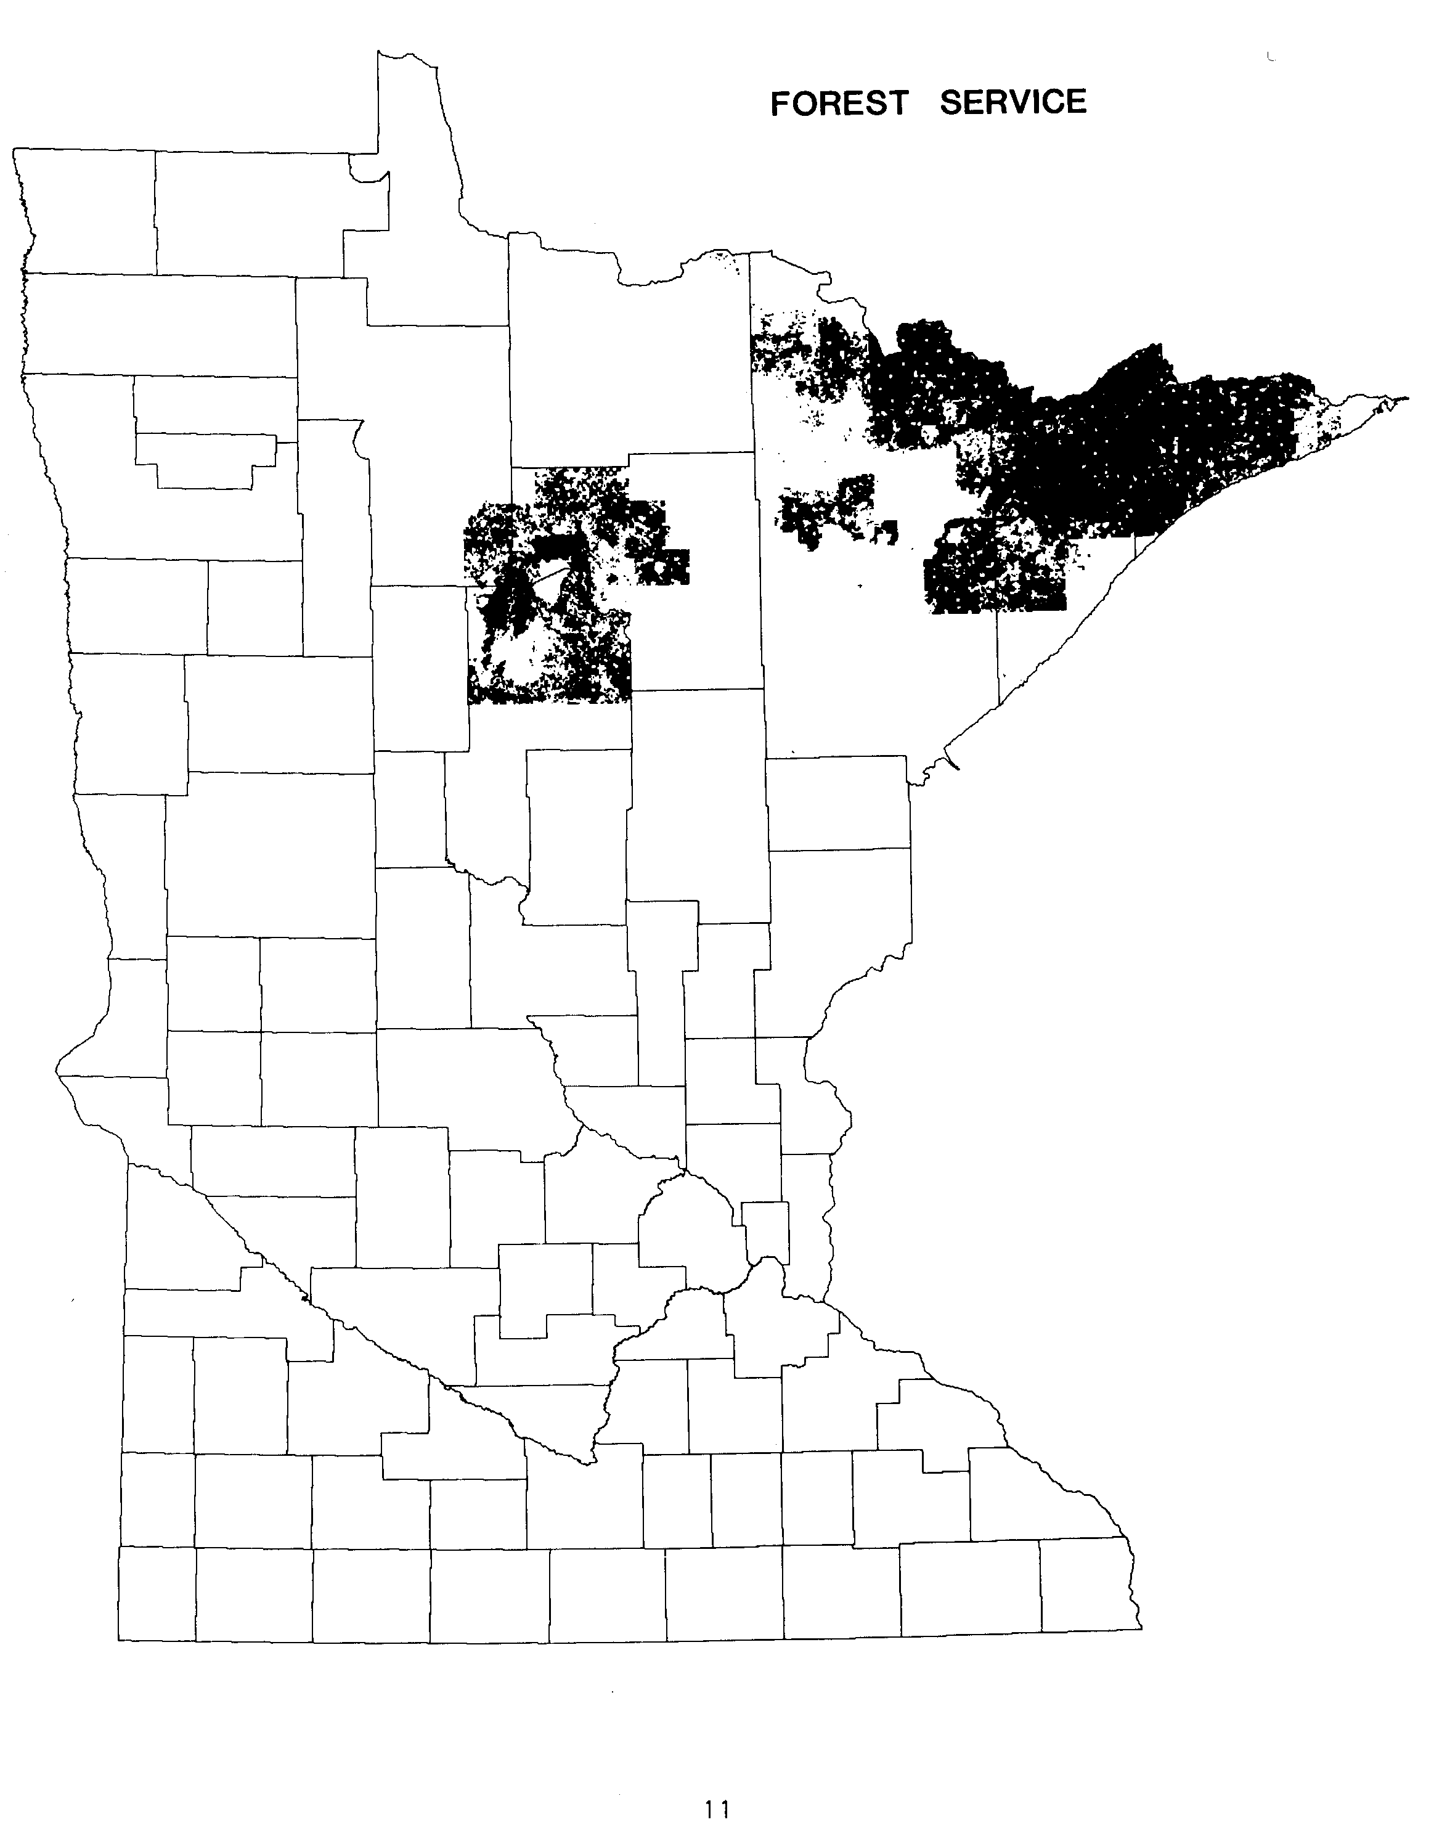

The U.S. Fish and Wildlife Service, part of the Department of the Interior, has fee title to nearly 400,000 acres of land in Minnesota. This makes the Fish and Wildlife Service the second largest federal land managing agency in the State with about 11% of all federal land. Approximately 174,100 acres of the total ownership are concentrated in 8 National Wildlife Refuges located in 14 counties. Another 126,500 acres of ownership are managed as Waterfowl Production Areas spread through 24 counties in the western half of the State. In addition, the Fish and Wildlife Service has title to 81,711 acres of "Land Utilization Project" lands in Beltrami, Lake of the Woods and Roseau counties. These "LUP" lands are leased to the Minnesota Department of Natural Resources and are included in the State's Red Lake Wildlife Management Area. (The Fish and Wildlife Service administers an additional 175,000 acres of Waterfowl Production easement lands which were not included in this inventory.)

All Fish and Wildlife Service lands are managed for wildlife production and habitat protection. Acquisition of National Wildlife Refuge land began with the Upper Mississippi Refuge in 1924. Acquisition for Waterfowl Production Areas, in both fee and easement, began in 1962. Virtually all Fish and Wildlife Service lands have been acquired by purchase, gift or exchange.

ESTIMATED ACREAGE OF PUBLIC LAND
FROM PREVIOUS AND CURRENT INVENTORIES

FISH AND WILDLIFE SERVICE
(Fee title land only, no easements)

YEAR AND INVENTORY ACREAGE
1950 FEDERAL AND STATE RURAL LAND 205,000
1960 MINNESOTA LANDS (Refuges only) 138,591
1965 MINNESOTA LAND OWNERSHIP 225,766
1977 PUBLIC LANDS IMPACT STUDY (1973 data) 339,000*
1978 DNR MAP SUPPLEMENT 413,680*
1979 PUBLIC LAND STATISTICS 388,561
1983 LMIC INVENTORY 382,735

* Estimate based on the number of 40-acre parcels containing such land.

For a complete list of inventories cited, see References, page 45.

12

NATIONAL PARK SERVICE

The National Park Service is part of the Department of the Interior. It administers over 133,000 acres of land in Minnesota. This makes the Park Service the third largest federal land manager in the State. The largest unit of management is Voyageurs National Park along the Canadian border in Koochiching and St. Louis counties. It contains over 128,000 acres. The Park Service also administers two National Monuments, Grand Portage in Cook county and Pipestone in Pipestone county. They contain about 709 and 282 acres, respectively. As part of the Upper St. Croix National Scenic River in Chisago and Pine counties, the Park Service administers about 2,400 acres. In addition, the Park Service administers about 2,000 acres in Chisago and Washington counties as part of the Lower St. Croix National Scenic River. (The Park Service also administers some easement lands along the St. Croix River which were not included in this inventory.)

Park Service lands are managed for preservation of natural and historic resources as well as for recreation. Nearly all Park Service land has been acquired by purchase, gift or exchange since the first unit (Pipestone) was established in 1937. Major land acquisition programs were conducted in the 1970s after the creation of Voyageurs National Park and both sections of the St. Croix National Scenic River.

ESTIMATED ACREAGE OF PUBLIC LAND
FROM PREVIOUS AND CURRENT INVENTORIES

NATIONAL PARK SERVICE
(Fee title land only, no easements)
YEAR AND INVENTORY ACREAGE
1950 FEDERAL AND STATE RURAL LAND less than 500
1960 MINNESOTA LANDS approximately 270
1965 MINNESOTA LAND OWNERSHIP 591
1977 PUBLIC LANDS IMPACT STUDY (1973 data) 1,600*
1978 DNR MAP SUPPLEMENT 138,640*
1979 PUBLIC LAND STATISTICS 125,360
1983 LMIC INVENTORY 133,455

* Estimate based on the number of 40-acre parcels containing such land.

For a complete list of inventories cited, see References, page 45.

14
BUREAU OF LAND MANAGEMENT
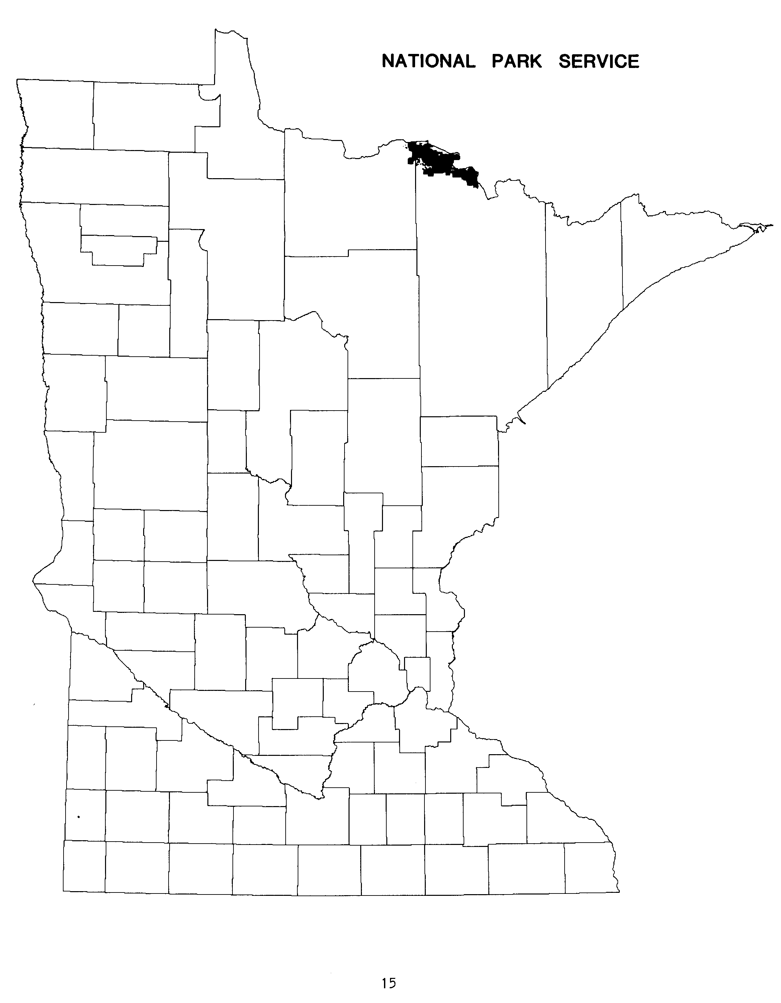

The U.S. Bureau of Land Management (BLM) is part of the Department of the Interior. BLM manages over 44,000 acres of vacant and unreserved public domain land in nearly all of Minnesota's 87 counties. BLM groups its land into two classes: islands and uplands. Over 2,200 acres of island lands are found in 82 counties with acreage totals ranging from 0.3 to over 180 acres. Upland acreage is found in 40 counties with 76% of the 41,849 upland acres concentrated in Koochiching county.

BLM lands are remaining federal lands which were never transferred or sold. On September 28, 1982, the agency has announced a plan to dispose of all of its surface acreage in the eastern half of the Nation through transfer or sale. The announcement stated:

"The plan includes the decision to transfer 81 islands and one upland tract to the National Park Service. The plan also includes decisions to transfer to state and local government agencies all of the remaining islands and a small number of upland tracts presently under BLM jurisdiction. Public sale of ten upland tracts and retention of 129 upland tracts (totaling 33,425 acres) to be used by other federal agencies as an exchange base with other government agencies or private entities is also included. Attempts will be made to exchange these lands for local government lands or private lands within the national forests, parks and refuges in Minnesota."

ESTIMATED ACREAGE OF PUBLIC LAND
FROM PREVIOUS AND CURRENT INVENTORIES

BUREAU OF LAND MANAGEMENT
YEAR AND INVENTORY ACREAGE
1950 FEDERAL AND STATE RURAL LAND 93,000
1960 MINNESOTA LANDS 82,139
1965 MINNESOTA LAND OWNERSHIP 40,698
1977 PUBLIC LANDS IMPACT STUDY (1973 data) 44,000*
1978 DNR MAP SUPPLEMENT 49,880*
1979 PUBLIC LAND STATISTICS 43,556
1983 LMIC INVENTORY 44,067

* Estimate based on the number of 40-acre parcels containing such land.

For a complete list of inventories cited, see References, page 45.

16
ARMY CORPS OF ENGINEERS
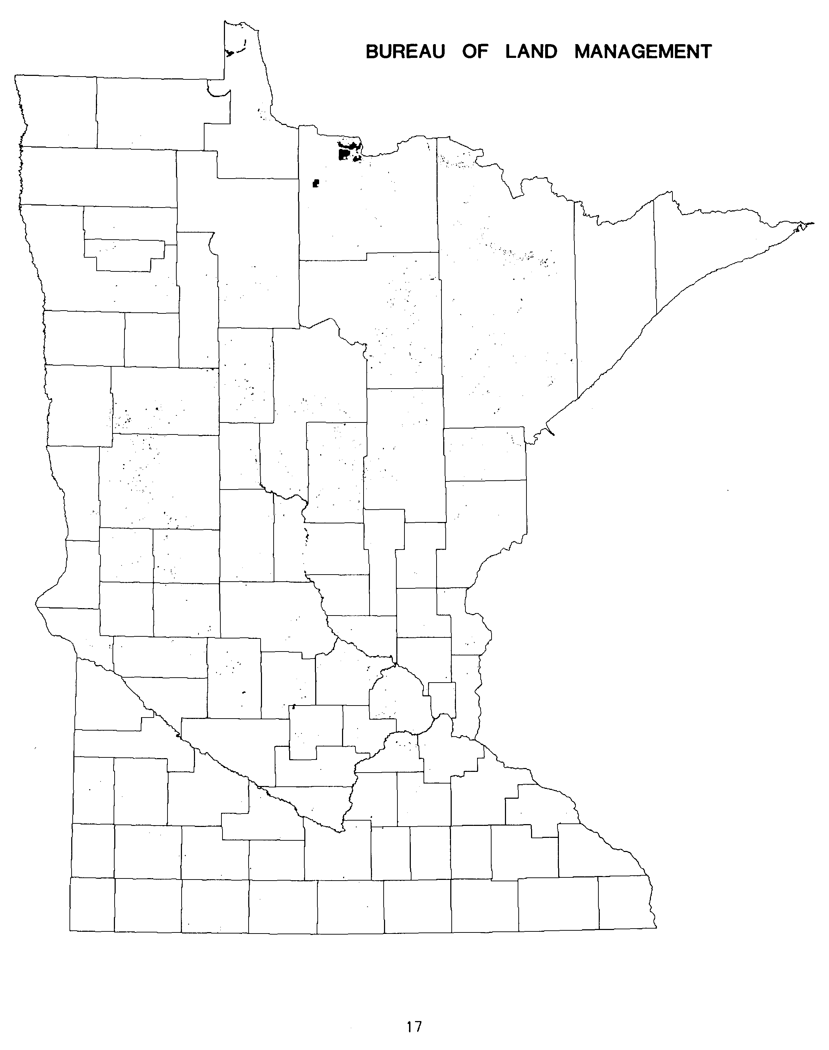

The U.S. Army Corps of Engineers is part of the Department of Defense. The Corps administers slightly over 24,000 acres of fee title lands in Minnesota. (The Corps also administers over 127,000 acres of various easement lands along the State's major waterways which were not included in this inventory.)

Corps lands are used primarily for navigation aid, flood control, and harbor facilities. In addition, the Corps has developed several public recreational sites. Early Corps lands were obtained in the late 1890s and 1900s with the construction of water control projects in the Mississippi River Headwaters. Most of the land for these projects was public domain land with limited amounts of acquired land. In the 1960s and 1970s major portions of this original public domain land was transferred to other public agencies with the Corps retaining over 200,000 acres of flowage rights on these lands. More recent lands acquired by the Corps are concentrated in the Mississippi River navigation areas below St. Paul and in selected flood control projects in western Minnesota.

ESTIMATED ACREAGE OF PUBLIC LAND
FROM PREVIOUS AND CURRENT INVENTORIES

ARMY CORPS OF ENGINEERS
(Fee title land only, no easements)
YEAR AND INVENTORY ACREAGE
1950 FEDERAL AND STATE RURAL LAND N/A
1960 MINNESOTA LANDS 277,423
1965 MINNESOTA LAND OWNERSHIP 262,200
1977 PUBLIC LANDS IMPACT STUDY (1973 data) 51,000*
1978 DNR MAP SUPPLEMENT 46,000*
1979 PUBLIC LAND STATISTICS 35,805
1983 LMIC INVENTORY 24,043

* Estimate based on the number of 40-acre parcels containing such land.

For a complete list of inventories cited, see References, page 45.

18
OTHER FEDERAL LAND
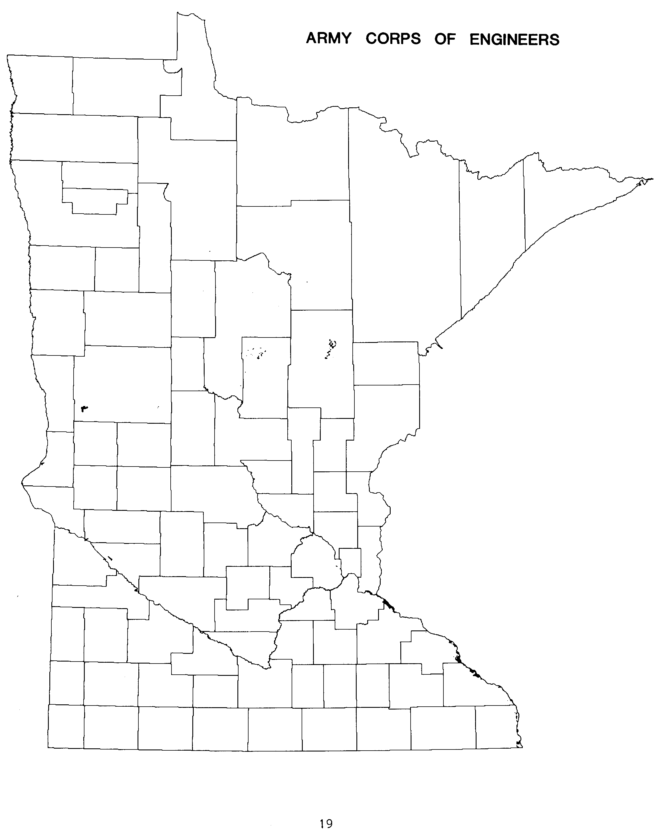

In addition to the five major federal land managing agencies discussed previously, an additional 19 federal agencies were inventoried. In total these 19 other agencies administer about 5,800 acres of land. This represents only 0.17% of all federally administered land. The acreage of most of these agencies tends to be rather small - a few military sites and many small administrative sites.

Virtually all of the federal land administered by these 19 agencies has been acquired by purchase, gift or exchange. Although several more federal agencies administer land now than in 1960, the actual acreage of land under these agencies has declined slightly. The other federal agencies inventoried were:

AGENCY ACREAGE
DEPARTMENT OF AGRICULTURE
SCIENCE/EDUCATION ADMINISTRATION 15.0
DEFENSE DEPARTMENT
DEPARTMENT OF THE AIR FORCE 1,146.0
DEPARTMENT OF THE ARMY 2,521.0
DEPARTMENT OF THE NAVY 117.5
DEPARTMENT OF ENERGY
WESTERN AREA POWER ADMINISTRATION 40.1
ENVIRONMENTAL PROTECTION AGENCY 13.2
GENERAL SERVICES ADMINISTRATION 83.6
DEPARTMENT OF HEALTH, EDUCATION AND WELFARE
HEALTH SERVICES ADMINISTRATION 3.7
SOCIAL SECURITY ADMINISTRATION 2.3
DEPARTMENT OF INTERIOR
GEOLOGICAL SURVEY 1.3
BUREAU OF MINES 71.9
DEPARTMENT OF JUSTICE
IMMIGRATION AND NATURALIZATION SERVICE 12.5
BUREAU OF PRISONS 560.0
DEPARTMENT OF LABOR
EMPLOYMENT AND TRAINING ADMINISTRATION 8.3
POSTAL SERVICE 131.7
DEPARTMENT OF TRANSPORTATION
COAST GUARD 261.4
FEDERAL AVIATION ADMINISTRATION 43.5
TREASURY DEPARTMENT
BUREAU OF CUSTOMS 3.0
VETERANS ADMINISTRATION 794.6
__________

TOTAL OTHER FEDERAL LAND# 5,830.6

# BUREAU OF INDIAN AFFAIRS LANDS NOT INCLUDED.

20
SECTION 2 - STATE LAND
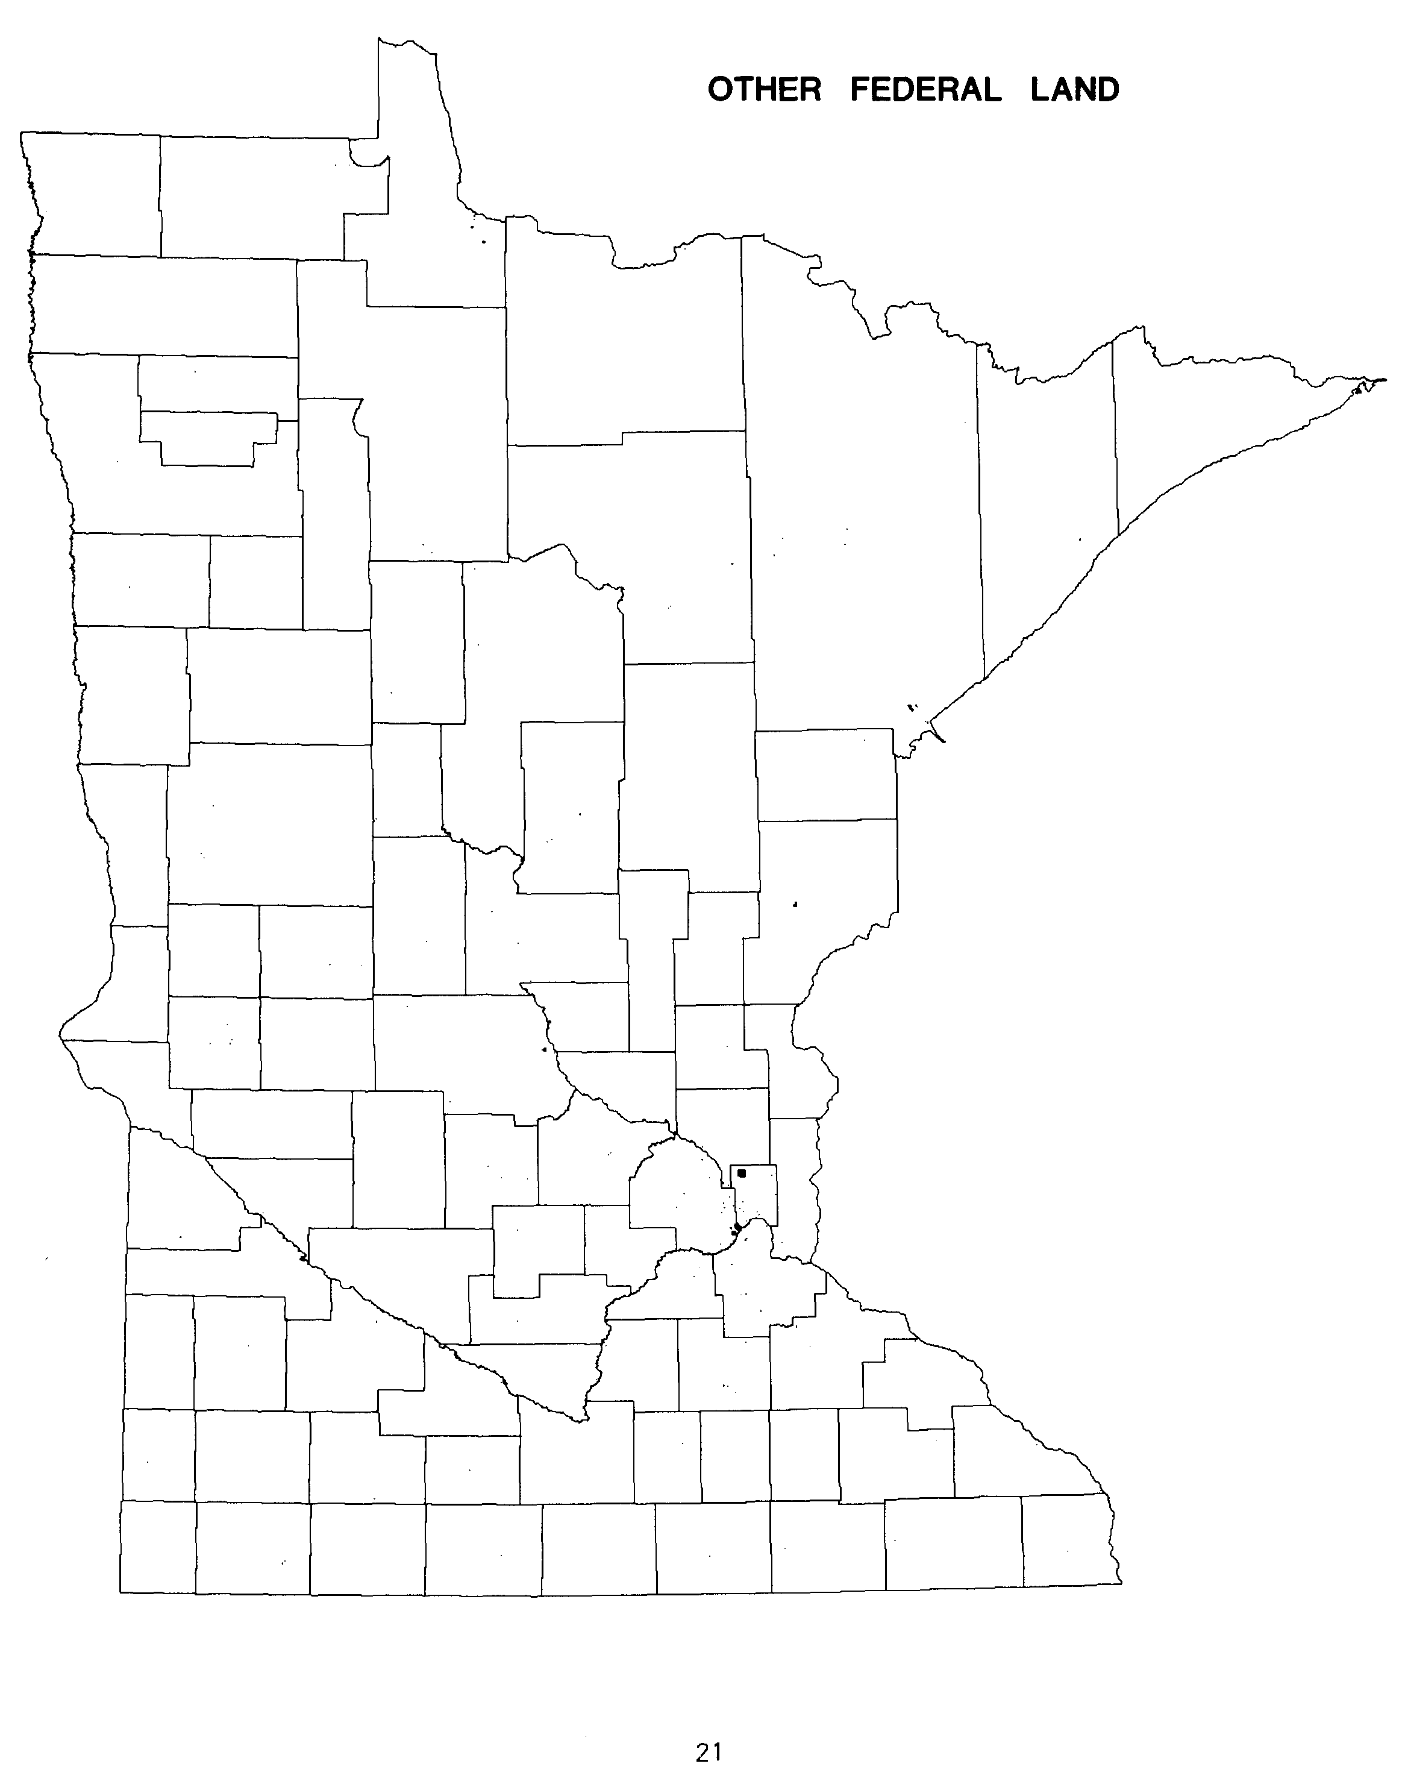

State land ownership began with the creation of the Minnesota Territory in 1849. Two sections of land in each township were granted to the State by the federal government. This and later federal land grants resulted in over 16 million acres of land being transferred into State ownership. Lands were granted to promote railroad construction, to reclaim swamplands, and to support public schools, internal improvements and the University. Initial policy for the State lands was to sell them into private ownership for cash. By 1912, only approximately 2.6 million acres of these original land grants remained in State ownership.

Starting at the end of the 1800s, the policy gradually changed to keeping land and mineral rights in State ownership. As early as the 1900s, the State began to acquire lands for conservation and other public purposes such as highways and state institutions. In the 1920s and 1930s, the State took title to several million acres (the so-called Conservation Area lands) when drainage bonds went forfeit for non-payment of taxes in 7 northwestern counties.

The State now administers approximately 5.6 million acres. This total represents just under 11.0% of the total land area of the State. Of the total, some 2.6 million acres (about 46% of the State land) remain from the original federal grants. Another 1.5 million acres (27% of the State land) came to the State from drainage bond forfeitures in the 1930s. The remaining 1.5 million acres have been acquired by the State during this century for various public purposes.

ESTIMATED ACREAGE OF PUBLIC LAND
FROM PREVIOUS AND CURRENT INVENTORIES

TOTAL STATE LAND
(Includes estimate for highway right of way land, unless noted)
YEAR AND INVENTORY ACREAGE
1960 MINNESOTA LANDS (DNR lands only) 5,028,000 $
1965 MINNESOTA LAND OWNERSHIP 5,350,523
1977 PUBLIC LANDS IMPACT STUDY (1975-1977 data) 5,480,435
1978 DNR MAP SUPPLEMENT 5,378,600 *$
1983 LEGISLATIVE AUDITOR’S REPORT (1982 data) 5,610,490 #
1983 LMIC AND DNR INVENTORIES 5,615,714
$ Excludes Department of Transportation right of way.
* Estimate based on the number of 40-acre parcels containing such land.
# Adjusted to include only State land and to exclude "excess" or "surplus" Department of Transportation lands.

For a complete list of inventories cited, see References, page 45.

22
DEPARTMENT OF NATURAL RESOURCES

The Minnesota Department of Natural Resources (DNR) is far and away the largest administrator of State lands. DNR administers over 5.2 million acres of land, some 94% of all land owned by the State. Starting with the creation of one of the Nation's oldest State Parks in 1892, the present DNR land base began to evolve.

Virtually all of the State’s remaining federal grant lands and Conservation Areas lands are administered by the DNR. Of the present DNR lands, about 48% are lands remaining from the original federal land grants. Another 30% of DNR lands are Conservation Areas lands obtained by the State in the 1920s and 1930s. Thus only about 1.1 million acres of DNR administered lands have been acquired by other means. Further, of these other acquired DNR lands, only 42.5% (some 488,000 acres) have been acquired by purchase.

In 1978 the DNR published a report on Public Land in Minnesota. The summary of DNR administered lands stated:

"More than half of the present state forest and state park system were established between 1930 and 1950. The vast majority of this land is either trust fund, conservation area, or county tax-forfeited lands acquired by the state through county board resolution. Acquisition of land from private owners is a relatively recent occurrence. The purchased land includes private inholdings within state parks, fish and wildlife habitat, public access to lakes and rivers, key state forest parcels, and lands acquired for other public purposes."

ESTIMATED ACREAGE OF PUBLIC LAND
FROM PREVIOUS AND CURRENT INVENTORIES

DEPARTMENT OF NATURAL RESOURCES

YEAR AND INVENTORY ACREAGE
1960 MINNESOTA LANDS 5,028,000
1965 MINNESOTA LAND OWNERSHIP 5,063,443
1977 PUBLIC LANDS IMPACT STUDY (1976 data) 5,208,328
1978 DNR MAP SUPPLEMENT 5,231,520
1983 LEGISLATIVE AUDITOR’S REPORT (1982 data) 5,275,534
1983 DNR INVENTORY 5,279,743

For a complete list of inventories cited, see References, page 45.

23
DNR FORESTRY DIVISION

The Forestry Division of DNR administers over 4.5 million acres. This represents approximately 86% of all DNR lands and 81% of all State lands. These lands are heavily concentrated in the northeastern third of the State. Of the Forestry total, two-thirds is located within the statutory boundary of the State's 55 State Forests. The remaining one third of Forestry administered lands are other DNR lands usually not within specific management units. However, over 8,000 acres of this land are located within the statutory boundaries of State Parks.

Forestry lands are managed primarily for forest production but also serve as wildlife habitat and as a recreation land resource. Of the Forestry lands within State Forests, nearly 54% are remaining federal grant lands. Another 30% are remaining conservation areas lands. Thus only 16% of State Forest lands have been acquired by other means. Only 4.4% of all State Forest lands have been acquired by purchase. During the period of Fiscal Years 1974 to 1982, slightly over 20,000 acres were acquired in fee for State Forests.

The Forestry lands outside of designated management units are virtually all remaining federal grant lands or conservation area lands. Only 2,812 of the 1.5 million acres have been acquired by other means. Of those acres outside of State Forests, only 408 acres have been purchased.

ESTIMATED ACREAGE OF PUBLIC LAND
FROM PREVIOUS AND CURRENT INVENTORIES

DNR FORESTRY DIVISION

YEAR AND INVENTORY ACREAGE
1960 MINNESOTA LANDS 3,387,147#
1965 MINNESOTA LAND OWNERSHIP 4,594,759#
1977 PUBLIC LANDS IMPACT STUDY (1976 data) 4,556,596
1978 DNR MAP SUPPLEMENT 4,555,150
1983 LEGISLATIVE AUDITOR'S REPORT (1982 data) 4,549,362
1983 DNR INVENTORY 4,548,885

# Forestry Division, plus Lands and Minerals Division.

For a complete list of inventories cited, see References, page 45.

24
DNR WILDLIFE DIVISION
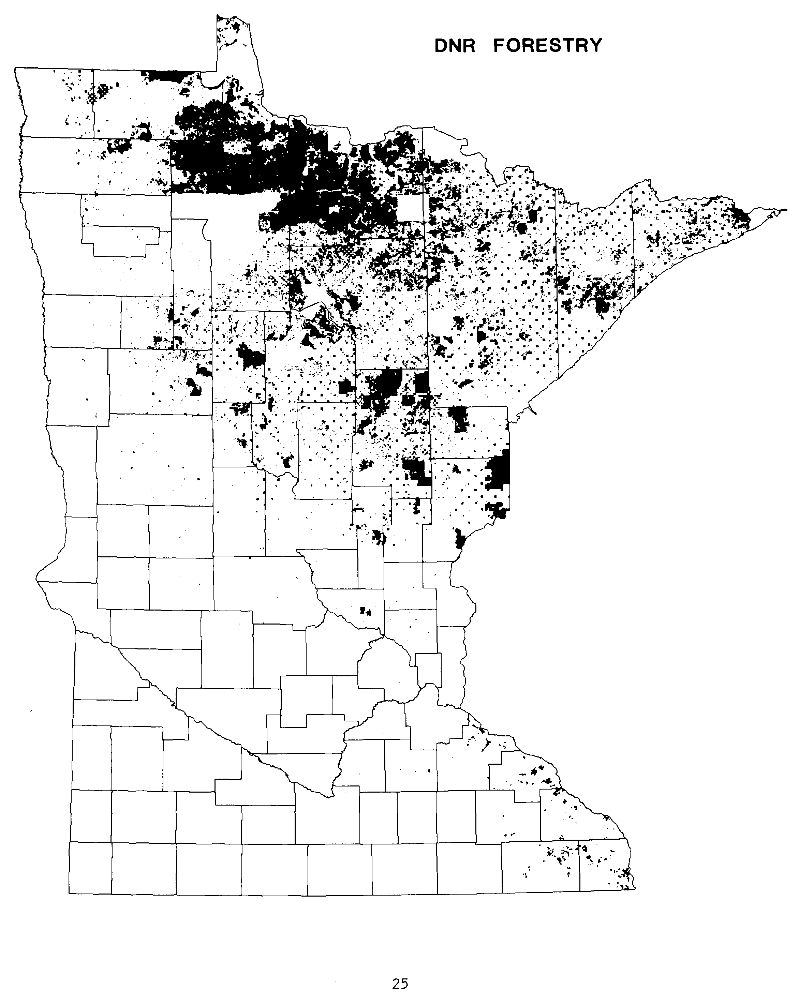

The DNR Wildlife Division administers over 500,000 acres. This amounts to about 10% of all DNR lands. Nine Wildlife Management Areas containing approximately 210,000 acres have resident managers. The remaining Wildlife acres are located in over 1200 smaller Management areas in virtually every county of the State. These areas are more heavily concentrated along the transitional farmlands from the State's northwestern to southeastern corners.

Wildlife Management Area lands are administered primarily for waterfowl production, but also serve as habitat for many other creatures and serve soil and water conservation needs. Less than 11% of all Wildlife lands are remaining federal grant lands or conservation area lands. All other Wildlife lands have been acquired by other means. Of the acquired lands, 55.6% (about 252,000 acres) have been purchased. During the period of Fiscal Years 1974 through 1982, over 60,000 acres have been acquired in fee for State Wildlife Lands.

ESTIMATED ACREAGE OF PUBLIC LAND
FROM PREVIOUS AND CURRENT INVENTORIES

DNR WILDLIFE DIVISION
YEAR AND INVENTORY ACREAGE
1960 MINNESOTA LANDS 238,001#
1965 MINNESOTA LAND OWNERSHIP 351,693#
1977 PUBLIC LANDS IMPACT STUDY (1976 data) 464,446
1978 DNR MAP SUPPLEMENT 479,494
1983 LEGISLATIVE AUDITOR'S REPORT (1982 data) 505,918
1983 DNR INVENTORY 509,598

# Game and Fish Division.

For a complete list of inventories cited, see References, page 45.

26
DNR PARKS AND RECREATION DIVISION
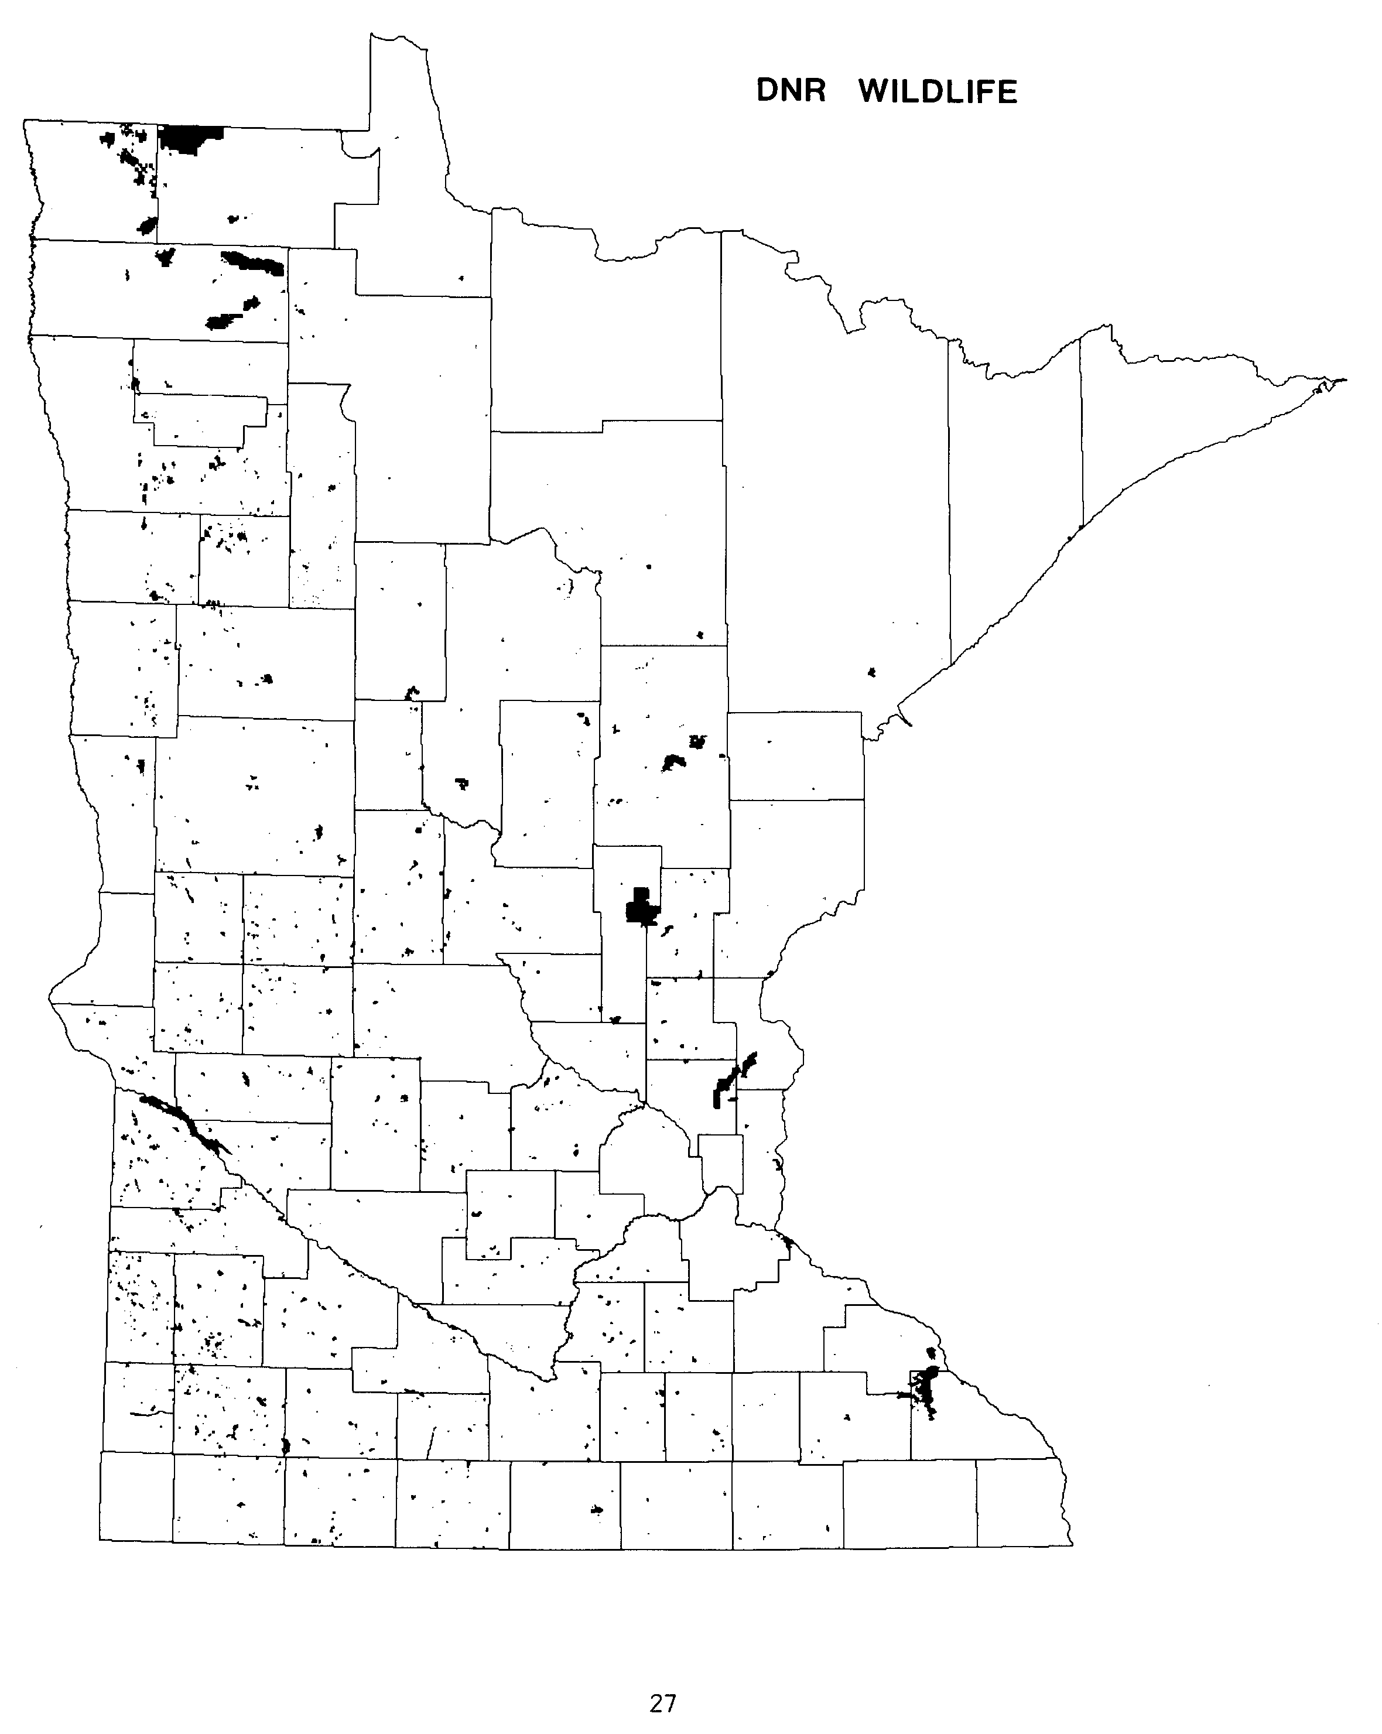

The DNR Parks and Recreation Division administers about 175,000 acres of land. This is about 3.3% of all DNR lands. Included in this acreage are 60 State Parks, 6 State Recreation Areas, and 18 State Waysides. The State Park system, which began with Itasca in 1891, now has about 200,000 acres within the statutory borders.

State Parks lands are managed for preservation of the State's natural heritage and for recreational use. Only 8% of Park lands are remaining federal grant lands or conservation area lands. Most Park lands have been acquired by other means. Of the acquired Park lands, about 54% have been purchased. Between Fiscal Years 1974 and 1982, nearly 43,000 acres have been acquired in fee for State Park and Recreation lands.

ESTIMATED ACREAGE OF PUBLIC LAND
FROM PREVIOUS AND CURRENT INVENTORIES

DNR PARKS AND RECREATION DIVISION
YEAR AND INVENTORY ACREAGE
1960 MINNESOTA LANDS 106,136
1965 MINNESOTA LAND OWNERSHIP 116,991
1977 PUBLIC LANDS IMPACT STUDY (1976 data) 153,738
1978 DNR MAP SUPPLEMENT 169,032
1983 LEGISLATIVE AUDITOR'S REPORT (1982 data) 174,830#
1983 DNR INVENTORY 174,848#

# The Auditor's report and the 1983 DNR inventory list about 188,000 acres for the Parks Division. However, over 13,000 acres have been administratively moved to other sections of DNR. See totals for Rivers, Trails and Scientific Areas on page 30.

For a complete list of inventories cited, see References, page 45.

28

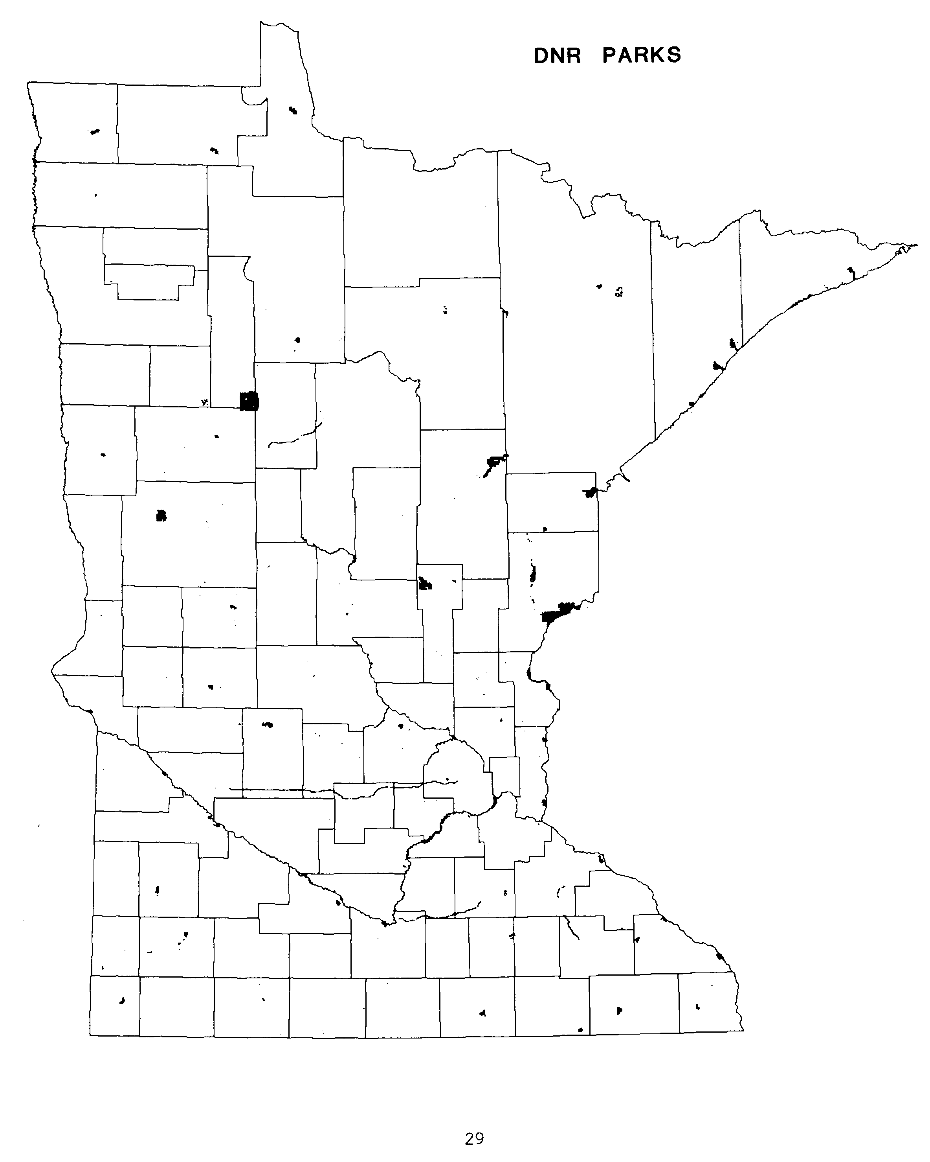
NOTE - This map slightly overrepresents lands presently under the control of the DNR Parks and Recreation Division. Some of the land shown on this map has been transferred to other divisions of DNR (see text).

OTHER DNR LAND

In addition to the three major DNR divisions listed previously, seven other divisions or sections administer over 46,000 acres. These other DNR lands are used for a great variety of things. Lands for the various River programs provide access and protection. Administration lands are either transferred to DNR from other State agencies or lands which are used for administrative offices. Fisheries lands and waters provide protection and propagation areas for game fish. Law enforcement and other public access lands were acquired for public access to lakes and rivers. Scientific and Natural Areas are created to protect unique natural land and water resources. State Trails provide for a variety of recreational activities in all seasons. Lands under the control of Waters or Minerals provide administrative sites for those programs.

With the exception of most Fisheries lands and some of the Trails lands, nearly of this acreage is a result of new DNR programs authorized by the Legislature in the 1970s. From Fiscal Years 1974 to 1982, over 10,000 acres were added to DNR administration for these programs.

The 1983 DNR inventory of lands administered by these other divisions and sections found the following:

DIVISION OR SECTION ACREAGE
CANOE AND BOATING RIVERS plus
WILD AND SCENIC RIVERS 1,450
DNR ADMINISTRATION 1,723
FISHERIES 26,410
LAW ENFORCEMENT AND PUBLIC ACCESS 2,618
SCIENTIFIC AND NATURAL AREAS 2,574
TRAILS 9,139
WATERS OR MINERALS 2,498
46,412

30

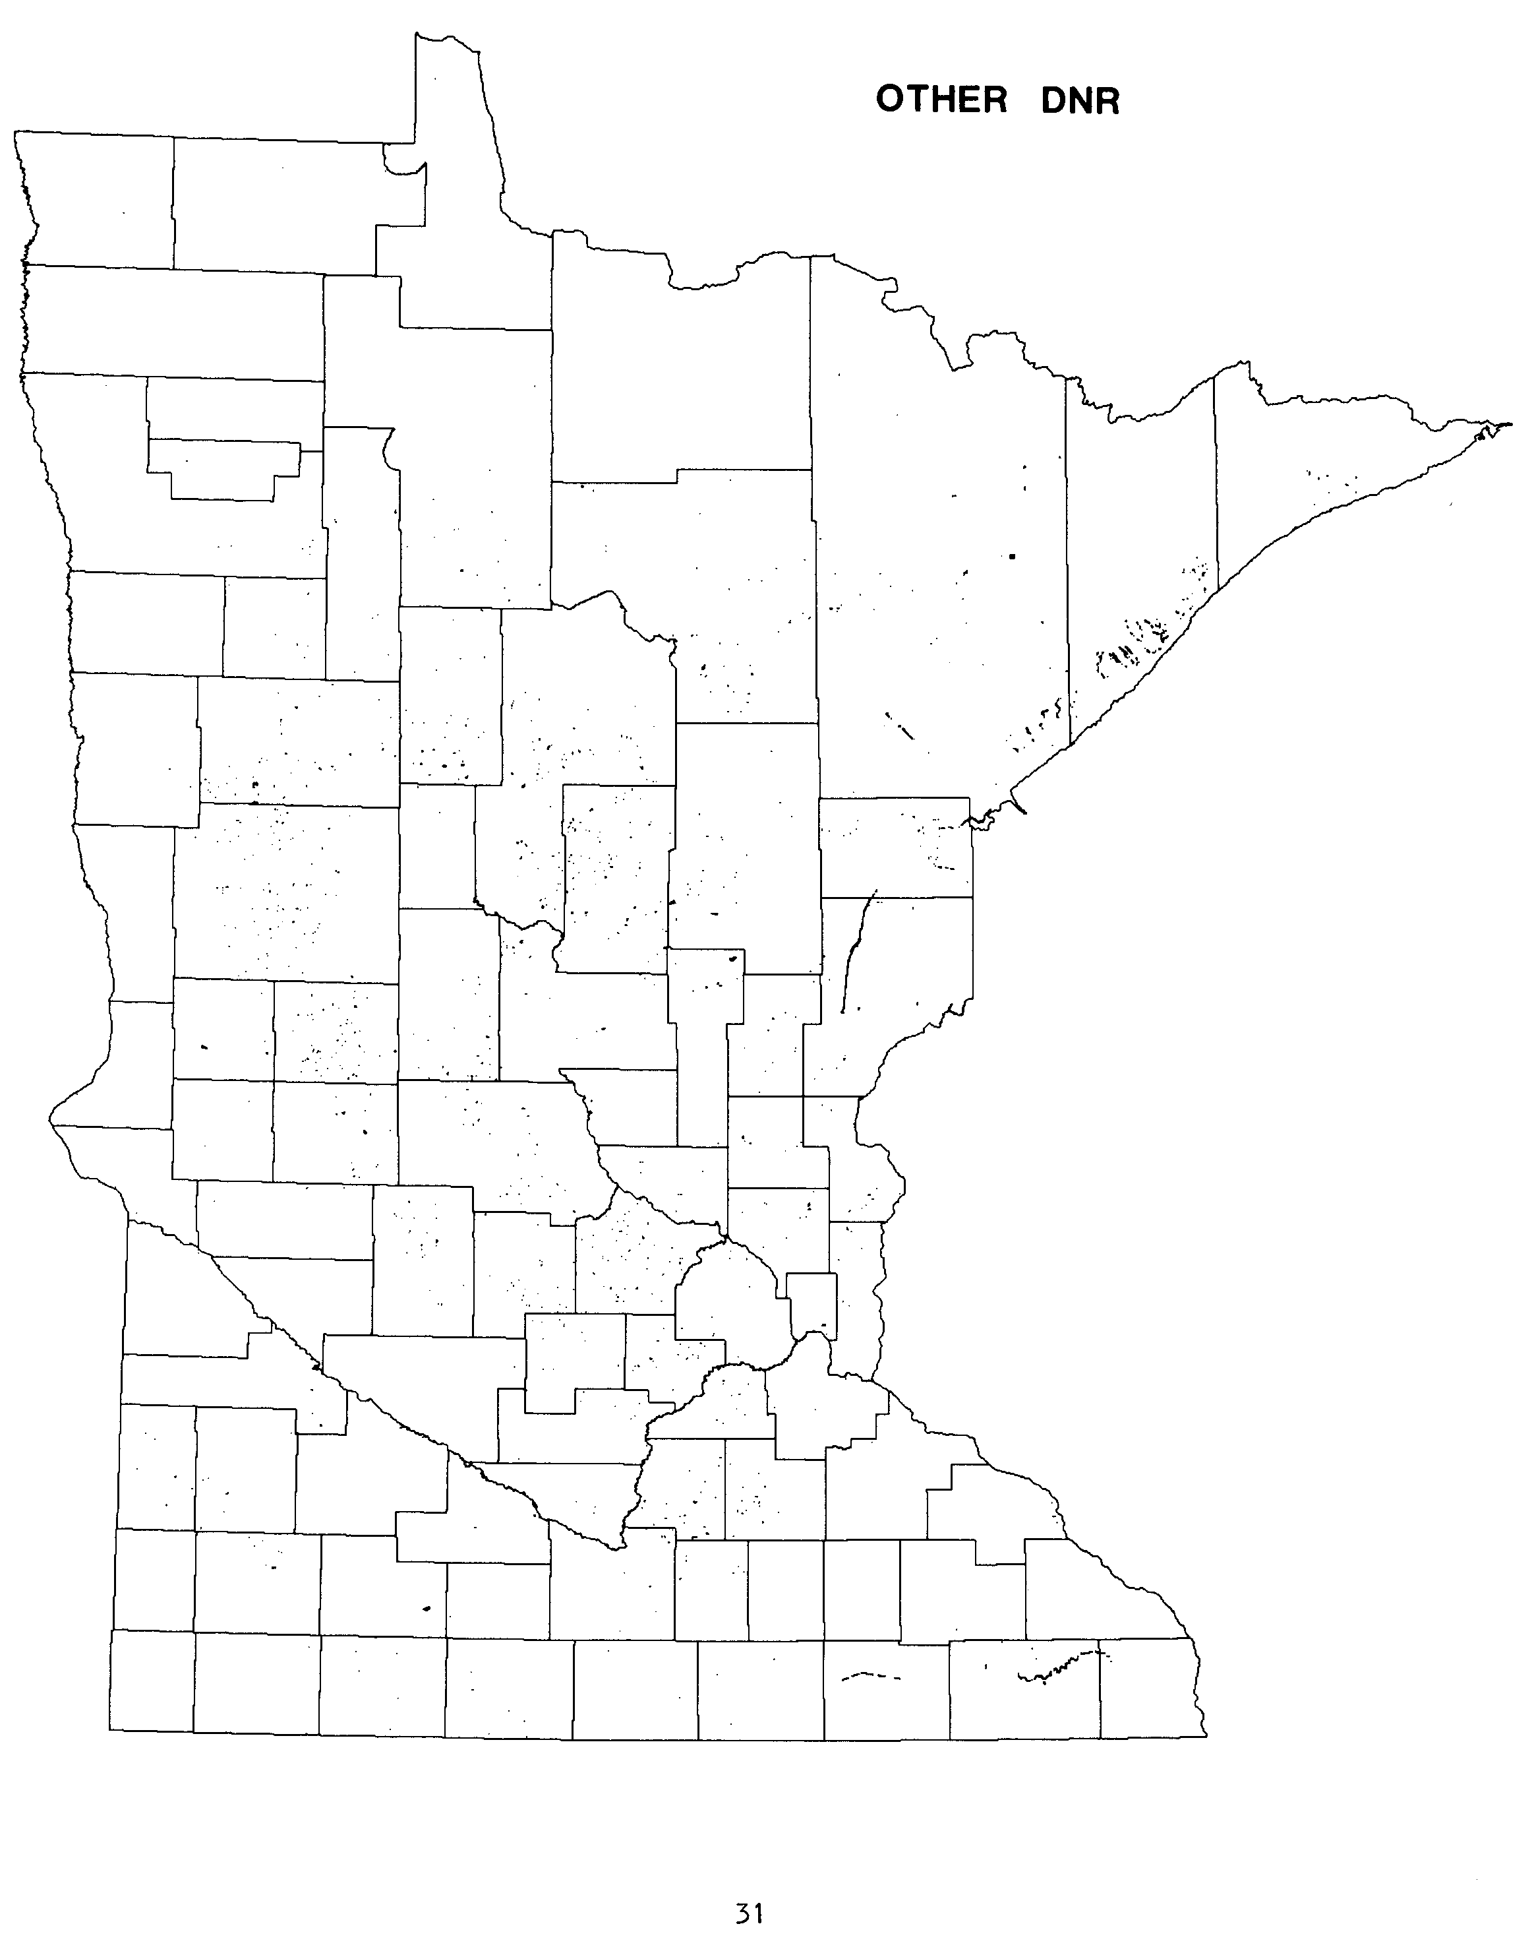
NOTE - This map slightly underrepresents lands presently under the control of "other" DNR divisions. Some of the land shown on the DNR Parks map has now been transferred to other divisions (see text).
DEPARTMENT OF TRANSPORTATION

Combining all of its various lands, the Department of Transportation (DOT) is the second largest administrator of State land. DOT manages over 239,000 acres, 4.2% of all State land. Over 96% of DOT land is right of way for the approximately 12,000 miles of State-maintained roads. Estimates for other types of DOT are as follows:

- Aeronautics 66.50
- Gravel Pits 5,156.20
- Headquarters, Maintenance and Storage 1,250.69#
- Rest Areas 2,209.60#
- Right of Way 230,681.00#

Estimated total for DOT 239,363.99

# The State estimated totals for these three DOT sections were printed in "Evaluation of State Land Acquisition and Disposal", Table 1.1, page 3, prepared by the Legislative Auditor in 1983. No detailed locational information was available to LMIC at the time this publication went to the printer. When that information becomes available, it will be added to the summary record system.

Between 1974 and 1982, DOT acquired over 18,900 acres. Nearly all of
this land was used for highway right of way.

ESTIMATED ACREAGE OF PUBLIC LAND
FROM PREVIOUS AND CURRENT INVENTORIES

DEPARTMENT OF TRANSPORTATION
YEAR AND INVENTORY ACREAGE
1960 MINNESOTA LANDS N/A
1965 MINNESOTA LAND OWNERSHIP 191,258
1977 PUBLIC LANDS IMPACT STUDY (1973 data) N/A
1978 DNR MAP SUPPLEMENT 43,360*#
1979 PUBLIC LAND STATISTICS 239,441
1983 LMIC INVENTORY 239,364

* Estimate based on the number of 40-acre parcels containing such land.
# Does not include most right of way land.

For a complete list of inventories cited, see References, page 45.

32

NOTE - This map of Department of Transportation (DOT) lands was compiled from several sources and slightly over represents DOT lands (see text).
MILITARY AFFAIRS

The Minnesota Department of Military Affairs is the third largest State land managing agency with over 52,000 acres. This represents only 0.9% of all State land. Over 99% of Military Affairs land is located in one area - Camp Ripley located just north of Little Falls in central Minnesota. In addition, the Department also administers nearly 70 National Guard Armories, 5 maintenance shops, 2 vehicle storage buildings and a motor vehicle compound in cities scattered around the State.

ESTIMATED ACREAGE OF PUBLIC LAND
FROM PREVIOUS AND CURRENT INVENTORIES

MILITARY AFFAIRS
YEAR AND INVENTORY ACREAGE
1960 MINNESOTA LANDS N/A
1965 MINNESOTA LAND OWNERSHIP 51,123
1977 PUBLIC LANDS IMPACT STUDY N/A
1978 DNR MAP SUPPLEMENT 55,080*
1983 LEGISLATIVE AUDITOR’S REPORT (1982 data) 52,839
1983 LMIC INVENTORY 52,400

* Estimate based on the number of 40-acre parcels containing such land.

For a complete list of inventories cited, see References, page 45.

34
UNIVERSITY OF MINNESOTA

The University of Minnesota is the fourth largest land holding agency in the State with over 32,000 acres under direct control. This is only about 0.6% of all State land. The land is concentrated in over 50 sites including campuses and related buildings, agricultural experiment stations, research and natural history centers, administrative centers, plus student and faculty housing areas. In addition, the University has received 6 areas of land in trusts from individuals. Further, nearly 6,000 acres in St. Louis and Cook counties are remaining "salt springs" lands from an original federal land grant.

In addition to the 32,000 acres under the direct control of the University, the Minnesota Department of Natural Resources administers over 30,000 acres of "University" trust fund lands. These remaining federal grant lands are located in many counties in northern Minnesota.

ESTIMATED ACREAGE OF PUBLIC LAND
FROM PREVIOUS AND CURRENT INVENTORIES

UNIVERSITY OF MINNESOTA
YEAR AND INVENTORY ACREAGE
1960 MINNESOTA LANDS N/A
1965 MINNESOTA LAND OWNERSHIP 30,587
1977 PUBLIC LANDS IMPACT STUDY N/A
1978 DNR MAP SUPPLEMENT 33,360*
1983 LEGISLATIVE AUDITOR'S REPORT (1982 data) 32,050
1983 LMIC INVENTORY 32,283

* Estimate based on the number of 40-acre parcels containing such land.

For a complete list of inventories cited, see References, page 45.

36
OTHER STATE LAND
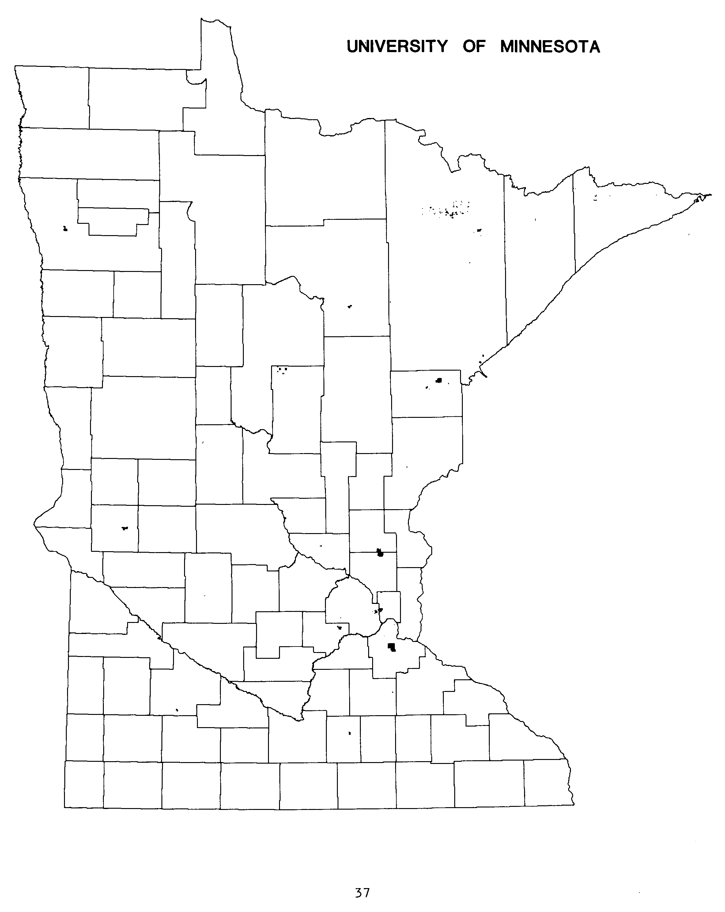

In addition to the previously listed State lands, 13 other State agencies or organizations administer nearly 12,000 acres of land. This represents only 0.2% of all State administered land.

These other state lands are managed for a great variety of uses. The largest acreage total is managed for the State Hospital system. Considerable land acreage is managed for the State University system, state historical preservation and interpretation, the State Community College system, and the State Correctional system. Remaining lands are used for State office buildings, research stations, the State Zoo, the State Fair grounds, and other educational or residential facilities.

AGENCY ACRES
DEPARTMENT OF ADMINISTRATION
(includes State Capitol area) 263.74
DEPARTMENT OF AGRICULTURE 13.30
DEPARTMENT OF CORRECTIONS 1,318.43
DEPARTMENT OF ECONOMIC SECURITY 1.93
DEPARTMENT OF EDUCATION 408.75
DEPARTMENT OF PUBLIC WELFARE 3,055.29
DEPARTMENT OF VETERANS AFFAIRS 315.70
IRON RANGE RESOURCES AND REHABILITATION 557.83
MINNESOTA AGRICULTURAL SOCIETY (STATE FAIR) 295.55
MINNESOTA HISTORICAL SOCIETY 1,914.15
MINNESOTA ZOO 480.00
STATE COMMUNITY COLLEGES 1,326.28
STATE UNIVERSITIES 1,973.09

TOTAL OTHER STATE LANDS 11,924.04

38
SECTION 3 - TAX-FORFEITED LAND

Shortly after Minnesota's settlement began, some land started going tax-forfeit for non-payment of taxes. Early State policy for these lands was to return them to the tax rolls as soon as possible. During the agricultural recessions of the 1920s, the first major wave of tax forfeiture began. Legislative measures were passed to make it easy for the original landowners to regain their land. With the depression of the 1930s, an even larger wave of tax forfeiture was recorded. By 1944 8.1 million acres of land were tax-forfeit. In 1950 records showed that 9.4 million acres had been on the tax-forfeited list at one time or another.

Beginning in the mid-1920s, Legislative action was begun to transfer some of this tax-forfeited land to other classifications. During the last 40 years, over half of the tax-forfeited lands have been disposed of, with a majority returning to the tax rolls. In more recent times, fewer land sales have resulted in retention of administration and management of these lands by the counties. Thus, about 2.8 million acres of these lands remain in state ownership, but are administered by the counties. County Board action has placed nearly half of these tax-forfeited lands within "memorial county forests". This has occurred in 14 counties. Most other tax-forfeited lands remain outside of county management units, but may be within State management units, such as State Forests.

ESTIMATED ACREAGE OF PUBLIC LAND
FROM PREVIOUS AND CURRENT INVENTORIES

TAX-FORFEITED LAND
YEAR AND INVENTORY ACREAGE
1960 MINNESOTA LANDS 4,793,000
1965 MINNESOTA LAND OWNERSHIP 3,824,448
1977 PUBLIC LANDS IMPACT STUDY (1976 data) 3,004,376
1978 DNR MAP SUPPLEMENT 2,808,627
1983 LEGISLATIVE AUDITOR'S REPORT (1982 data) 2,800,021
1983 DNR INVENTORY 2,797,237

For a complete list of inventories cited, see References, page 45.

40
SECTION 4 - METROPOLITAN COMMISSIONS LAND
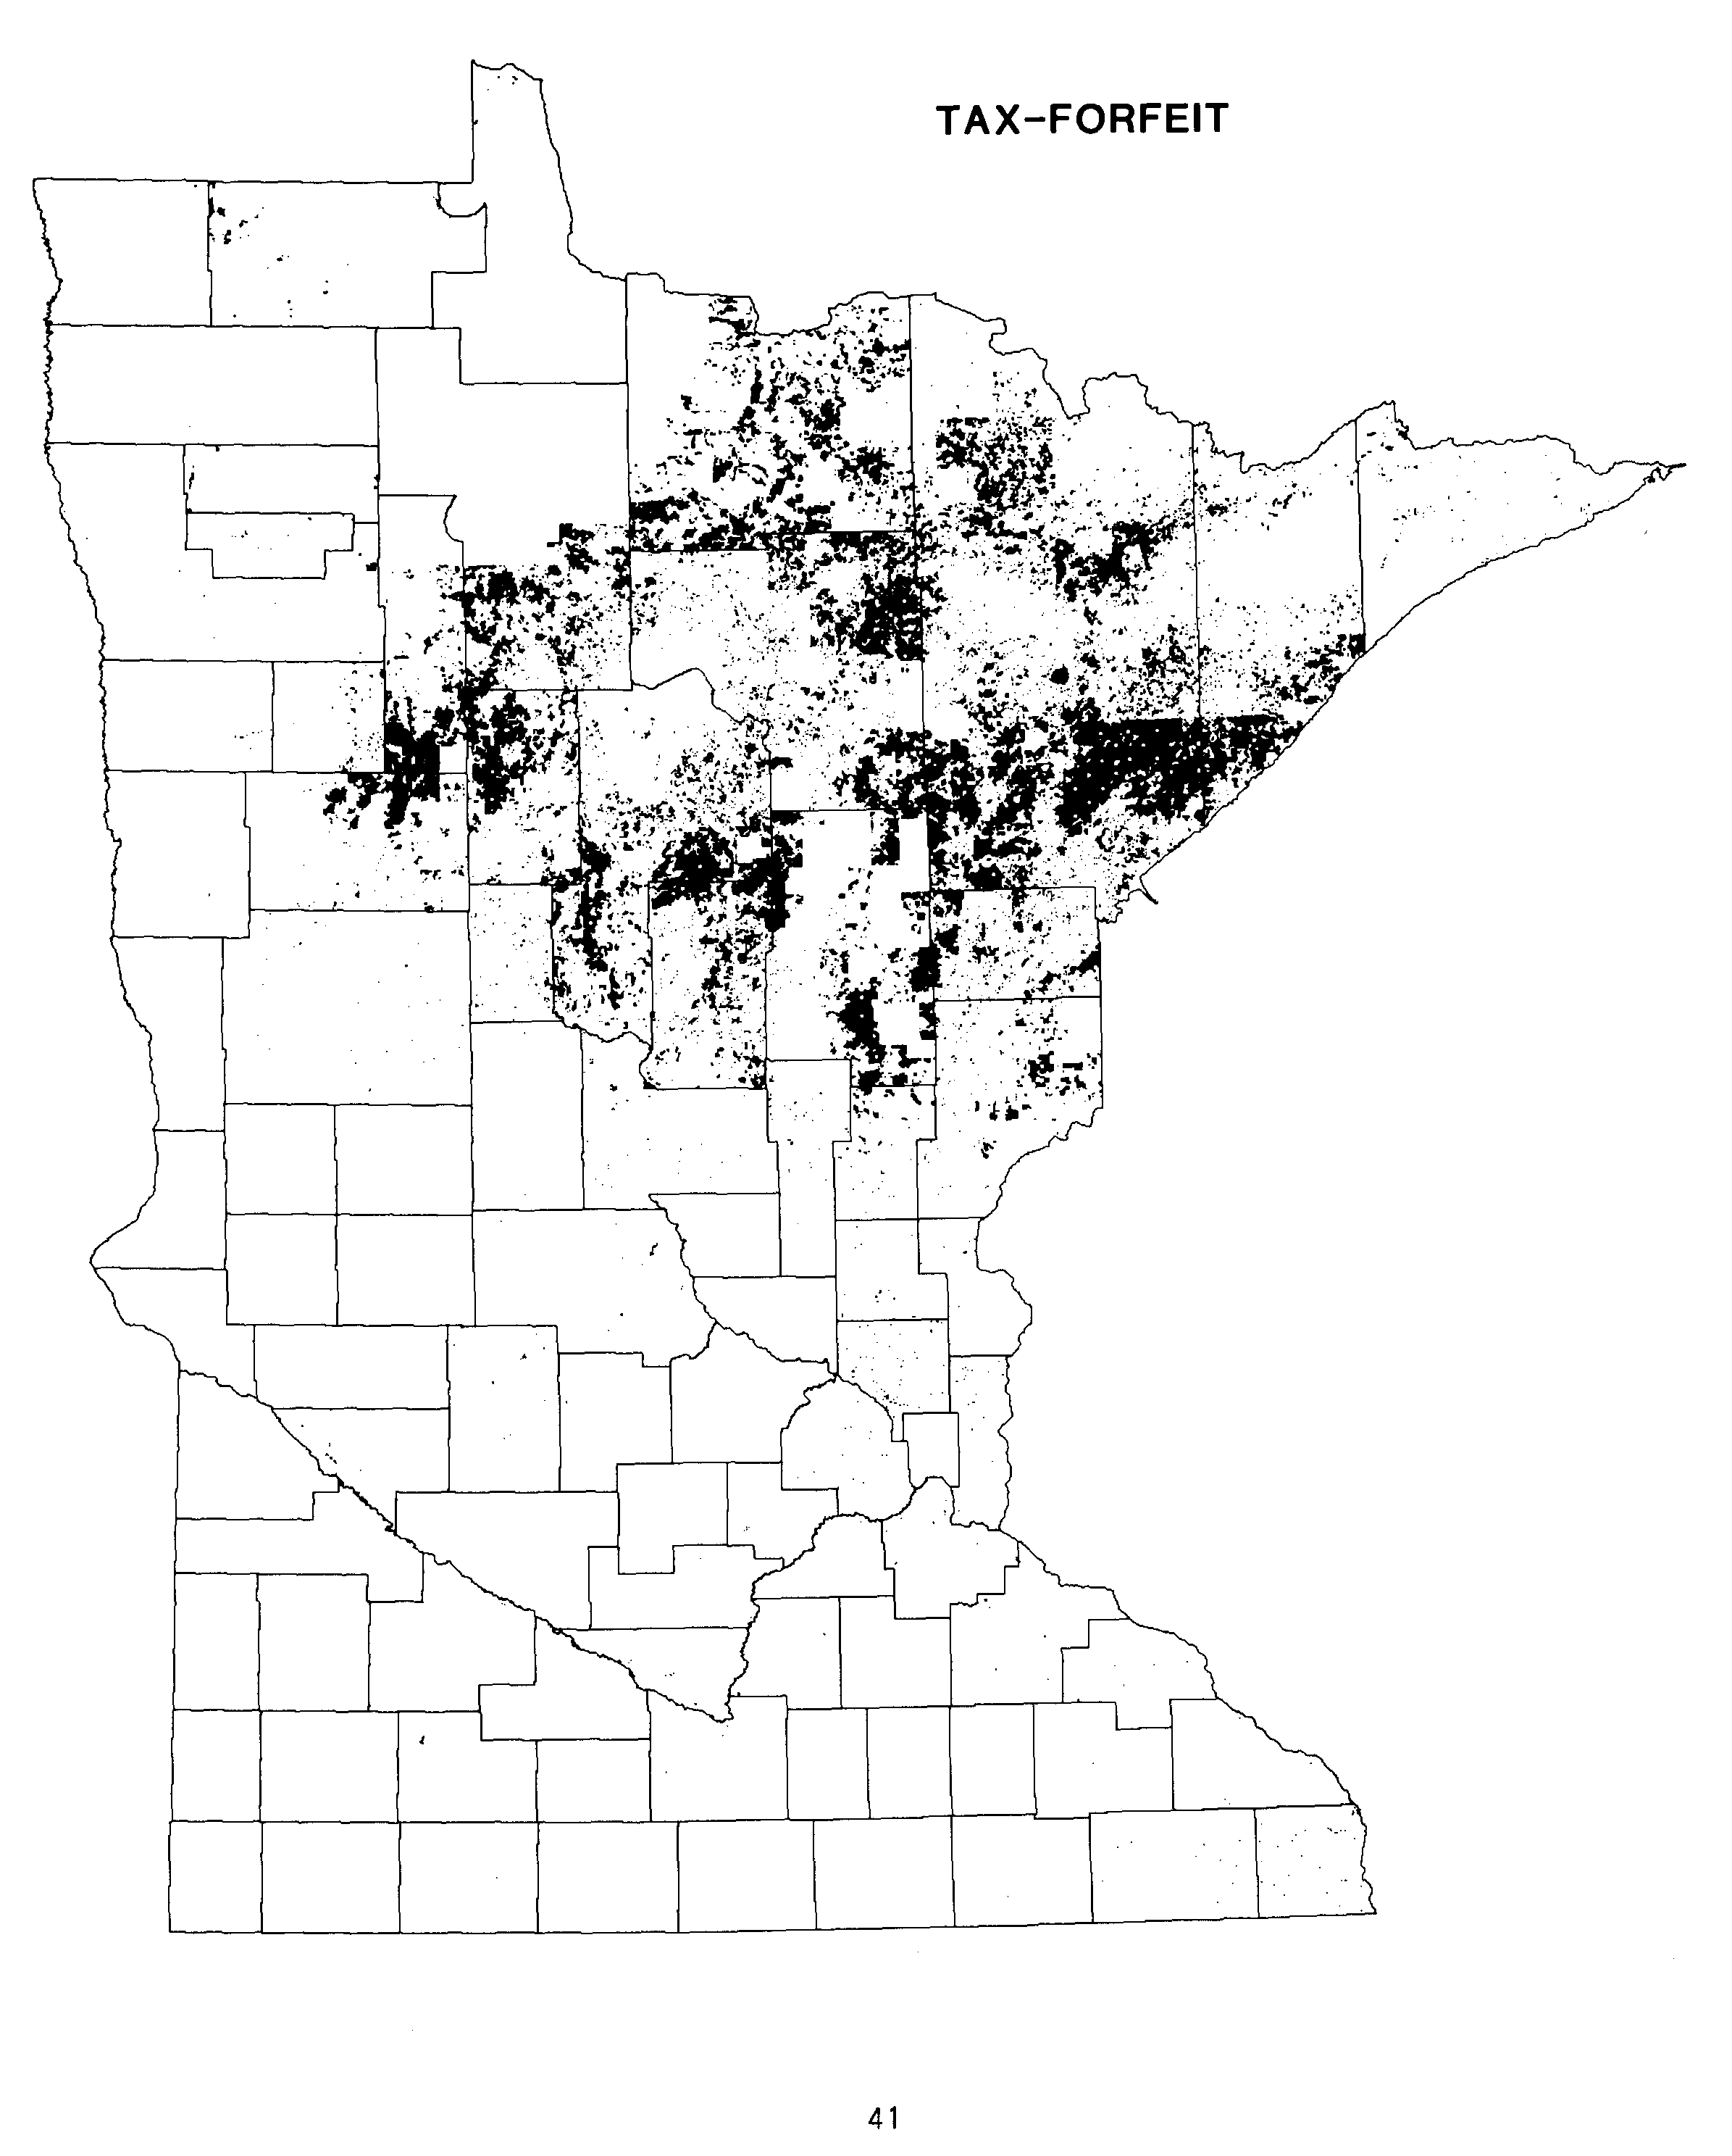

Three Commissions in the 7-county Twin Cities metropolitan area administer over 9,000 acres of land.

The Metropolitan Airports Commission (MAC) administers the Minneapolis-St. Paul International Airport and 6 regional airports in 5 of the 7 metropolitan counties.

Airport Acres
Mpls-St. Paul International 2,908.86
Air Lake 573.30
Anoka County 1,897.46
Crystal 423.60
Flying Cloud 566.70
Lake Elmo 626.00
St. Paul Downtown 549.10
MAC TOTAL 7,545.02

The Metropolitan Waste Control Commission (MWCC) administers over 1,600 acres of land. The Commission operates 14 waste water treatment plants with at least one plant in each metropolitan county. Plant areas range in size from 1.07 acres to 459.42 acres.

MWCC TOTAL 1,641.86

The Metropolitan Transit Commission (MTC) administers about 60 acres in Hennepin and Ramsey counties. These sites are used for bus garages, a bus overhaul garage, park and ride sites and a bus turnaround site.
MTC TOTAL 60.65

42
REFERENCES

1950 FEDERAL AND STATE RURAL LANDS, by R. D. Davidson, U.S. Department of Agriculture, BAE Circular No. 909, summary table reprinted in The Federal Lands: Their Use and Management by Marion Clawson and Burnell Held, University of Nebraska Press, 1957, Appendix Table 1.

1960 MINNESOTA LANDS, by Samuel T. Dana, John H. Allison, and Russell N. Cunningham, The American Forestry Association, 1960.

1965 MINNESOTA LAND OWNERSHIP, by Waldemar R. Anderson, Roland E. Olson and John R. Borchert, for the Minnesota Outdoor Recreation Resources Commission, February 1, 1965.

1977 MINNESOTA PUBLIC LANDS IMPACT STUDY for the Legislative Commission on Minnesota Resources in cooperation with the Tax Study Commission and Barton-Ashman Associates, Inc. Phase 1: Natural Resource Lands.

1978 DNR MAP SUPPLEMENT, STATE OF MINNESOTA, PUBLIC LAND OWNERSHIP, 1978, Text Supplement to Map, produced by the Minnesota Department of Natural Resources, Office of Planning and Research, in cooperation with the Legislative Commission on Minnesota Resources, May, 1979.

1979 PUBLIC LAND STATISTICS, 1979, Bureau of Land Management, U.S. Department of the Interior, sold by the Superintendent of Documents, Washington, DC, 20402 (produced annually).

1983 LEGISLATIVE AUDITOR’S REPORT, EVALUATION OF STATE LAND ACQUISITION AND DISPOSAL, Office of the Legislative Auditor, Program Evaluation Division, March 14, 1983.

45

(note: page 44 is blank)

TABLE 1 - FEDERAL OWNERSHIP OF LAND IN MINNESOTA, BY AGENCY, 1960
AS OF JUNE 30, 1959 (in acres)

AGENCY PUBLIC DOMAIN ACQUIRED TOTAL
------ ------------- -------- -----
DEPARTMENT OF AGRICULTURE
AGRIC. RESEARCH SERVICE 15.0 15.0
FOREST SERVICE 1,140,477.0 1,645,910.0 2,786,387.0
COMMODITY CREDIT CORP. 1.9 1.9

DEPARTMENT OF DEFENSE
DEPARTMENT OF THE AIR FORCE 1,512.0 1,512.0
DEPARTMENT OF THE ARMY 2,959.0 2,959.0
DEPARTMENT OF THE NAVY 174.0 174.0
CORPS OF ENGINEERS 234,903.6 25,733.2 260,636.8

GENERAL SERVICES ADMIN. 50.8 50.8

DEPARTMENT OF HEALTH, EDUCATION & WELFARE
PUBLIC HEALTH SERVICE 6.5 6.5

HOUSING AND HOME FINANCE AGENCY
PUBLIC HOUSING ADMIN. 2.0 2.0

DEPARTMENT OF INTERIOR
FISH AND WILDLIFE SERVICE 282.1 202,016.0 202,298.1
BUREAU OF INDIAN AFFAIRS 28,667.4 28,667.4
BUREAU OF LAND MANAGEMENT 75,979.0 75,979.0
BUREAU OF MINES 57.2 57.2
NATIONAL PARK SERVICE 3.5 272.4 275.9
BUREAU OF RECLAMATION 17.0 17.0

DEPARTMENT OF JUSTICE
BUREAU OF PRISONS 2,965.0 2,965.0

POST OFFICE DEPARTMENT
BUREAU OF FACILITIES 32.0 32.0

TREASURY DEPARTMENT
U.S. COAST GUARD 10.0 14.1 24.1

VETERANS ADMIN. 1,517.8 1,517.8

----------- ----------- ----------
TOTAL FEDERAL LAND 1,451,655.0 1,911,923.0 3,363,578.0

Data from "STATISTICAL APPENDIX TO THE ANNUAL REPORT OF THE DIRECTOR, BUREAU OF LAND MANAGEMENT" for the fiscal year ended June 30, 1960.

47

(note: page 46 is blank)

TABLE 2 - FEDERAL OWNERSHIP OF LAND IN MINNESOTA, BY AGENCY, 1970
AS OF JUNE 30, 1969 (in acres)

AGENCY PUBLIC DOMAIN ACQUIRED TOTAL
------ ------------- -------- ----

DEPARTMENT OF AGRICULTURE
AGRIC. RESEARCH SERVICE 15.0 15.0
FOREST SERVICE 1,116,683.0 1,663,789.0 2,780,472.0

DEFENSE DEPARTMENT
DEPARTMENT OF THE AIR FORCE 1,641.0 1,641.0
DEPARTMENT OF THE ARMY 3,335.0 3,335.0
DEPARTMENT OF THE NAVY 174.6 174.6
CORPS OF ENGINEERS 126,010.6 24,025.4 150,036.0

GENERAL SERVICES ADMIN. 84.5 84.5

DEPARTMENT OF HEALTH, EDUCATION & WELFARE
SOCIAL SECURITY ADMIN. .4 .4

HEALTH SERVICES AND MENTAL HEALTH ADMIN. 3.7 3.7

DEPARTMENT OF INTERIOR
FISH AND WILDLIFE SERVICE 288.0 292,189.8 292,477.8
GEOLOGICAL SURVEY 1.3 1.3
BUREAU OF INDIAN AFFAIRS 28,697.9 28,697.9
BUREAU OF LAND MANAGEMENT 43,923.0 43,923.0
BUREAU OF MINES 62.9 62.9
NATIONAL PARK SERVICE 275.9 315.0 590.9
BUREAU OF RECLAMATION 44.1 44.1
FEDERAL WATER POLLUTION CONTROL ADMIN. 13.2 13.2

DEPARTMENT OF JUSTICE
IMMIGRATION AND
NATURALIZATION SERVICE 4.9 4.9
BUREAU OF PRISONS 2,965.0 2,965.0

POST OFFICE DEPARTMENT
BUREAU OF FACILITIES 29.1 29.1

DEPARTMENT OF TRANSPORTATION
U.S. COAST GUARD 10.0 16.5 26.5
FEDERAL AVIATION ADMIN. 8.3 8.3

TREASURY DEPARTMENT
BUREAU OF CUSTOMS 6.0 6.0

VETERANS ADMIN. 686.3 686.3

----------- ----------- ----------
TOTAL FEDERAL LAND 1,287,190.5 2,018,108.9 3,305,299.4

Data from "PUBLIC LAND STATISTICS, 1970" produced by the U.S. Bureau of Land Management in cooperation with the General Services Administration.

48
TABLE 3 - FEDERAL OWNERSHIP OF LAND IN MINNESOTA, BY AGENCY, 1981
AS OF FISCAL YEAR 1979 (in acres)

AGENCY PUBLIC DOMAIN ACQUIRED TOTAL
------ ------------- -------- -----
DEPARTMENT OF AGRICULTURE
FOREST SERVICE 1,110,168.0 1,684,817.0 2,794,985.0
SCIENCE/EDUCATION ADMIN. 15.0 15.0

DEFENSE DEPARTMENT
DEPARTMENT OF THE AIR FORCE 1,146.0 1,146.0
DEPARTMENT OF THE ARMY 2,521.0 2,521.0
DEPARTMENT OF THE NAVY 110.8 110.8
CORPS OF ENGINEERS 11,742.7 24,062.0 35,804.7

DEPARTMENT OF ENERGY
WESTERN AREA POWER ADMIN. 40.1 40.1

ENVIRONMENTAL PROTECTION AGENCY 13.2 13.2

GENERAL SERVICES ADMIN. 83.6 83.6

DEPARTMENT OF HEALTH, EDUCATION & WELFARE
HEALTH SERVICES ADMIN. 3.7 3.7
SOCIAL SECURITY ADMIN. 2.3 2.3

DEPARTMENT OF INTERIOR
FISH AND WILDLIFE SERVICE 288.2 388,272.7 388,560.9
GEOLOGICAL SURVEY 1.3 1.3
BUREAU OF INDIAN AFFAIRS 28,697.9 28,697.9
BUREAU OF LAND MANAGEMENT 43,556.0 43,556.0
BUREAU OF MINES 81.5 81.5
NATIONAL PARK SERVICE 125,359.8 125,359.8

DEPARTMENT OF JUSTICE
IMMIGRATION AND
NATURALIZATION SERVICE 12.5 12.5
BUREAU OF PRISONS 560.0 560.0

DEPARTMENT OF LABOR
EMPLOYMENT & TRAINING ADMIN. 8.3 8.3

U.S. POSTAL SERVICE 121.2 121.2

DEPARTMENT OF TRANSPORTATION
U.S. COAST GUARD 10.0 249.1 259.1
FEDERAL AVIATION ADMIN. 240.8 240.8

TREASURY DEPARTMENT
BUREAU OF CUSTOMS 6.0 6.0

VETERANS ADMIN. 813.2 813.2
------ ------------- -------- -----

TOTAL FEDERAL LAND 1,165,764.9 2,257,239.0 3,423,003.9

Data from "PUBLIC LAND STATISTICS, 1981" produced by the U.S. Bureau of Land Management in cooperation with the General Services Administration.
NOTE: OWNERSHIP DATA REPRINTED FROM 1979 REPORT. NO CHANGE IN ACREAGES.

49
TABLE 4 - FEDERAL LAND (EXCEPT BUREAU OF INDIAN AFFAIRS) BY COUNTY, 1983
(from 1983 LMIC Inventory)

NOTE - Rows and columns may not add due to rounding.

FOREST FISH AND NATL PARK BUREAU OF CORPS OF OTHER TOTAL
COUNTY SERVICE WILDLIFE SERVICE LAND MAN. ENGINEERS FEDERAL FEDERAL
------ ------- -------- --------- --------- --------- ------- -------
AITKIN 0 14,276 0 164 1,116 0 15,556
ANOKA 0 0 0 19 0 86 105
BECKER 0 45,039 0 147 0 0 45,187
BELTRAMI 63,462 4,308 0 31 5 4 67,810
BENTON 0 0 0 36 0 0 36
BIG STONE 0 9,762 0 13 11 0 9,786
BLUE EARTH 0 0 0 25 0 2 27
BROWN 0 0 0 1 0 1 2
CARLTON 0 0 0 241 0 * 241
CARVER 0 344 0 3 0 0 347
CASS 290,347 0 0 304 52 9 290,712
CHIPPEWA 0 0 0 13 204 17 235
CHISAGO 0 0 1,841 15 3 0 1,859
CLAY 0 8,376 0 8 0 1 8,386
CLEARWATER 0 0 0 25 0 0 25
COOK 648,356 0 710 99 0 16 649,180
COTTONWOOD 0 1,010 0 4 0 1 1,015
CROW WING 0 0 0 175 494 12 681
DAKOTA 0 0 0 56 1,001 107 1,163
DODGE 0 0 0 0 0 0 0
DOUGLAS 0 7,566 0 26 0 1 7,593
FARIBAULT 0 0 0 3 0 0 3
FILLMORE 0 0 0 0 0 * *
FREEBORN 0 474 0 0 0 1 475
GOODHUE 0 0 0 15 4,954 4 4,973
GRANT 0 7,961 0 18 0 0 7,979
HENNEPIN 0 1,012 0 19 46 1,056 2,133
HOUSTON 0 11,981 0 0 3,315 * 15,296
HUBBARD 0 0 0 289 7 * 296
ISANTI 0 0 0 2 0 4 6
ITASCA 309,603 0 0 1,084 11 7 310,705
JACKSON 0 2,288 0 15 0 0 2,303
KANABEC 0 0 0 40 0 0 40
KANDIYOHI 0 9,801 0 95 0 0 9,896
KITTSON 0 0 0 94 0 6 100
KOOCHICHING 248 0 10,805 32,026 0 7 43,085
LAC QUI PARLE 0 12,033 0 0 337 1 12,371
LAKE 760,310 0 0 1 0 102 760,413
LAKE OF THE WOODS 0 49,210 0 5,599 0 301 55,110
LE SUEUR 0 0 0 5 0 4 9
LINCOLN 0 0 0 2 0 0 2
LYON 0 0 0 2 0 * 3
MC LEOD 0 296 0 34 0 * 331
MAHNOMEN 0 4,809 0 0 0 0 4,809

50
TABLE 4 - FEDERAL LAND (EXCEPT BUREAU OF INDIAN AFFAIRS) BY COUNTY, 1983 (CONT.)
(from 1983 LMIC Inventory)

NOTE - Rows and columns may not add due to rounding.

FOREST FISH AND NATL PARK BUREAU OF CORPS OF OTHER TOTAL
COUNTY SERVICE WILDLIFE SERVICE LAND MAN. ENGINEERS FEDERAL FEDERAL
------ ------- -------- --------- --------- --------- ------- -------
MARSHALL 0 61,052 0 0 0 0 61,052
MARTIN 0 0 0 2 0 * 2
MEEKER 0 1,172 0 54 0 3 1,230
MILLE LACS 0 1 0 40 0 0 41
MORRISON 0 0 0 169 0 1 170
MOWER 0 0 0 0 0 * *
MURRAY 0 0 0 * 0 0 *
NICOLLET 0 0 0 4 0 * 5
NOBLES 0 0 0 0 0 3 3
NORMAN 0 0 0 2 0 * 2
OLMSTED 0 0 0 0 0 0 0
OTTER TAIL 0 16,595 0 227 1,985 8 18,815
PENNINGTON 0 0 0 2 0 1 3
PINE 0 2,240 1,851 46 0 560 4,697
PIPESTONE 0 118 282 0 0 2 402
POLK 0 8,005 0 38 0 1 8,044
POPE 0 12,054 0 31 0 0 12,086
RAMSEY 0 152 0 19 9 2,415 2,594
RED LAKE 0 0 0 12 0 0 12
REDWOOD 0 0 0 5 0 1 5
RENVILLE 0 0 0 9 0 0 9
RICE 0 0 0 13 0 7 21
ROCK 0 0 0 0 0 0 0
ROSEAU 0 28,193 0 1,183 0 43 29,419
ST LOUIS 751,719 0 117,222 869 110 752 870,672
SCOTT 0 2,088 0 24 0 1 2,113
SHERBURNE 0 29,608 0 89 0 0 29,697
SIBLEY 0 0 0 4 0 4 8
STEARNS 0 6,841 0 148 2 222 7,213
STEELE 0 0 0 0 0 0 0
STEVENS 0 7,340 0 0 0 36 7,376
SWIFT 0 6,069 0 11 220 0 6,299
TODD 0 375 0 17 0 1 392
TRAVERSE 0 2,815 0 0 597 0 3,412
WABASHA 0 3,346 0 1 4,910 6 8,263
WADENA 0 0 0 54 0 * 54
WASECA 0 0 0 12 0 1 12
WASHINGTON 0 0 744 64 572 1 1,381
WATONWAN 0 0 0 14 0 * 14
WILKIN 0 1,247 0 9 0 1 1,257
WINONA 0 2,426 0 0 4,083 4 6,514
WRIGHT 0 382 0 146 0 3 531
YELLOW MEDICINE 0 70 0 5 0 0 75
--------- ------- ------- ------ ------ ----- --------
STATE TOTAL 2,824,044 382,735 133,455 44,067 24,043 5,831 3,414,176

* = LESS THAN ONE HALF ACRE.

51
TABLE 5 - DEPARTMENT OF NATURAL RESOURCES LAND, 1983
(from 1983 DNR Inventory)

NOTE - Rows and columns may not add due to rounding.

FORESTRY FORESTRY
(IN STATE (OUTSIDE OTHER TOTAL
COUNTY FOREST) FOREST) WILDLIFE PARKS DNR DNR
------ --------- -------- -------- ----- ------ ---------
AITKIN 257,418 101,694 18,864 11,574 640 390,190
ANOKA 2 682 15,814 0 421 16,919
BECKER 35,507 9,650 5,316 3,333 1,714 55,520
BELTRAMI 275,222 285,020 2,117 1,266 303 563,928
BENTON 0 120 991 0 17 1,128
BIG STONE 0 94 6,021 902 44 7,061
BLUE EARTH 0 7 1,370 982 201 2,560
BROWN 0 0 1,811 836 94 2,741
CARLTON 49,060 15,848 400 8,549 2,162 76,019
CARVER 0 0 270 0 575 845
CASS 134,041 45,597 5,760 175 2,415 187,988
CHIPPEWA 0 11 9,198 0 54 9,263
CHISAGO 24 121 8,729 6,575 329 15,778
CLAY 0 678 4,820 1,009 59 6,566
CLEARWATER 20,017 10,797 3,627 20,226 490 55,157
COOK 76,089 49,260 80 6,559 795 132,783
COTTONWOOD 0 5 5,052 0 339 5,396
CROW WING 7,937 15,930 2,834 1,243 1,395 29,339
DAKOTA 56 8 2,085 878 813 3,840
DODGE 0 0 80 190 2 272
DOUGLAS 0 160 4,034 1,118 348 5,660
FARIBAULT 0 0 2,216 0 2 2,218
FILLMORE 7,892 0 0 2,400 529 10,821
FREEBORN 0 0 551 1,516 7 2,074
GOODHUE 5,511 0 546 1,321 131 7,509
GRANT 0 0 3,318 0 212 3,530
HENNEPIN 0 5 67 484 631 1,187
HOUSTON 12,141 0 15 693 67 12,916
HUBBARD 66,246 12,494 3,924 4,945 760 88,369
ISANTI 1 240 3,543 0 174 3,958
ITASCA 233,817 83,146 1,729 807 641 320,140
JACKSON 0 0 2,816 202 61 3,079
KANABEC 11,179 3,246 9,077 0 45 23,547
KANDIYOHI 0 200 3,156 2,079 453 5,888
KITTSON 0 14,760 39,934 2,125 9 56,828
KOOCHICHING 880,691 211,594 0 118 9 1,092,412
LAC QUI PARLE 0 0 14,663 752 6 15,421
LAKE 108,443 52,035 601 10,225 11,420 182,724
LAKE OF THE WOODS 261,127 173,862 681 2,826 77 438,573
LE SUEUR 0 80 2,279 382 424 3,165
LINCOLN 0 0 5,724 0 53 5,777
LYON 0 0 8,276 1,574 119 9,969
MC LEOD 0 1 1,775 0 331 2,107
MAHNOMEN 16,710 5,821 9,514 1,137 15 33,197

52
TABLE 5 - DEPARTMENT OF NATURAL RESOURCES LAND, 1983 (CONT.)
(from 1983 DNR Inventory)

NOTE - Rows and columns may not add due to rounding.

FORESTRY FORESTRY
(IN STATE (OUTSIDE OTHER TOTAL
COUNTY FOREST) FOREST) WILDLIFE PARKS DNR DNR
------ --------- -------- -------- ----- ------ ---------
MARSHALL 2 49,756 65,795 287 1 115,841
MARTIN 0 51 1,921 0 49 2,021
MEEKER 0 40 1,840 0 288 2,168
MILLE LACS 13,296 6,957 33,311 9,004 640 63,208
MORRISON 0 3,215 4,131 293 230 7,869
MOWER 0 0 713 781 187 1,681
MURRAY 0 0 6,819 906 417 8,142
NICOLLET 0 47 216 274 61 598
NOBLES 0 0 1,626 0 4 1,630
NORMAN 0 320 5,858 0 0 6,178
OLMSTED 631 0 2,561 0 160 3,352
OTTER TAIL 1 2,562 8,037 7,866 536 19,002
PENNINGTON 0 2,340 2,568 0 0 4,908
PINE 128,787 12,015 1,388 35,832 3,052 181,074
PIPESTONE 0 0 1,310 234 8 1,552
POLK 0 1,219 16,309 0 13 17,541
POPE 0 235 2,596 1,280 242 4,353
RAMSEY 0 0 0 150 101 251
RED LAKE 0 855 1,279 113 2 2,249
REDWOOD 0 0 3,170 0 62 3,232
RENVILLE 0 0 468 43 10 521
RICE 0 500 1,435 1,038 157 3,130
ROCK 0 0 0 1,396 0 1,396
ROSEAU 75,631 112,294 64,728 2,118 18 254,789
ST LOUIS 301,670 235,117 2,047 4,632 5,388 548,854
SCOTT 0 1 493 0 3,389 3,883
SHERBURNE 5,359 120 308 0 376 6,163
SIBLEY 0 41 683 0 654 1,378
STEARNS 477 298 1,883 0 129 2,787
STEELE 0 0 1,156 481 0 1,636
STEVENS 0 0 2,530 20 12 2,562
SWIFT 0 0 7,181 187 11 7,379
TODD 0 3,267 7,429 0 138 10,834
TRAVERSE 0 40 110 0 6 156
WABASHA 9,525 0 5,514 206 184 15,429
WADENA 19,737 3,383 1,077 0 36 24,233
WASECA 0 0 1,769 0 29 1,798
WASHINGTON 0 0 1,612 2,795 100 4,507
WATONWAN 0 0 941 0 2 943
WILKIN 0 0 3,743 0 0 3,743
WINONA 6,791 2 22,015 3,416 49 32,273
WRIGHT 0 0 3,730 1,442 283 5,455
YELLOW MEDICINE 0 0 3,619 1,053 11 4,683
--------- --------- ------- ------- ------ ---------
STATE TOTAL 3,021,040 1,527,845 509,598 174,848 46,412 5,279,743

53
TABLE 6 - NON-DNR STATE LAND, 1983
(from 1983 LMIC Inventory)

NOTE - Rows and columns may not add due to rounding.

DOT DOT OTHER MILITARY UNIV. OF OTHER TOTAL NON-DNR
COUNTY AERO. GRAV.PITS DOT# AFFAIRS MINNESOTA STATE LAND STATE LAND#
------ ----- --------- ------- ------ ---------- ---------- -------------
AITKIN 0 136 # 1 0 0 137
ANOKA 0 8 # 1 2,887 480 3,376
BECKER 0 44 # 2 0 0 46
BELTRAMI 0 111 # 5 0 324 440
BENTON 0 14 # 0 0 1 15
BIG STONE 0 28 # * 0 0 28
BLUE EARTH 0 0 # * 0 354 354
BROWN 0 17 # 2 0 0 19
CARLTON 0 127 # 3 3,758 175 4,063
CARVER 0 0 # 0 955 0 955
CASS 0 127 # 0 69 219 415
CHIPPEWA 0 49 # 1 0 19 69
CHISAGO 0 0 # 0 0 1 1
CLAY 0 31 # 1 0 102 134
CLEARWATER 0 23 # 0 0 0 23
COOK 0 642 # 0 607 0 1,249
COTTONWOOD 0 23 # 1 0 80 104
CROW WING 0 79 # 5 1,520 312 1,916
DAKOTA 0 30 # 7 7,973 793 8,803
DODGE 0 0 # 0 0 0 0
DOUGLAS 5 5 # * 0 0 10
FARIBAULT 0 0 # 0 0 0 0
FILLMORE 0 0 # 0 0 19 19
FREEBORN 0 30 # 1 0 0 31
GOODHUE 0 12 # 5 0 208 225
GRANT 0 29 # 0 0 0 29
HENNEPIN 0 46 # 13 283 314 656
HOUSTON 0 26 # 0 0 0 26
HUBBARD 1 65 # * 0 0 66
ISANTI 0 0 # 0 2,230 245 2,475
ITASCA 0 134 # 1 620 105 860
JACKSON 0 0 # 5 0 0 5
KANABEC 0 47 # 0 0 0 47
KANDIYOHI 0 39 # 2 3 238 282
KITTSON 0 30 # 0 0 0 30
KOOCHICHING 0 798 # 0 0 153 951
LAC QUI PARLE 0 25 # 2 0 0 27
LAKE 0 198 # 0 160 25 383
LAKE OF THE WOODS 0 61 # 0 0 0 61
LE SUEUR 0 18 # 0 0 * 18
LINCOLN 0 5 # 0 0 0 5
LYON 0 32 # 7 0 216 255
MC LEOD 0 14 # 5 0 0 19
MAHNOMEN 0 7 # 0 0 0 7

54
TABLE 6 - NON-DNR STATE LAND, 1983 (CONT.)
(from 1983 LMIC Inventory)

NOTE - Rows and columns may not add due to rounding.

DOT DOT OTHER MILITARY UNIV. OF OTHER TOTAL NON-DNR
COUNTY AERO. GRAV.PITS DOT# AFFAIRS MINNESOTA STATE LAND STATE LAND#
------ ----- --------- ------- ------ ---------- ---------- -------------
MARSHALL 0 127 # 0 0 0 127
MARTIN 0 4 # 5 0 0 9
MEEKER 0 0 # 1 0 0 1
MILLE LACS 0 22 # 1 0 109 132
MORRISON 0 35 # 52,063 0 17 52,115
MOWER 0 0 # 5 0 61 66
MURRAY 0 0 # 0 0 0 0
NICOLLET 0 9 # 3 0 847 859
NOBLES 0 0 # * 0 72 72
NORMAN 0 57 # 0 0 0 57
OLMSTED 0 0 # 12 0 172 184
OTTER TAIL 0 95 # 1 0 788 884
PENNINGTON 0 34 # 2 0 66 102
PINE 0 110 # 5 80 169 364
PIPESTONE 0 7 # 1 0 0 8
POLK 0 46 # 6 1,565 0 1,617
POPE 0 61 # 0 0 0 61
RAMSEY 0 0 # 20 1,010 453 1,483
RED LAKE 0 31 # 0 0 0 31
REDWOOD 0 0 # * 400 241 641
RENVILLE 0 6 # 1 0 80 87
RICE 0 18 # 5 30 921 974
ROCK 0 28 # 1 0 0 29
ROSEAU 61 82 # 0 0 0 143
ST LOUIS 0 599 # 168 5,778 1,200 7,745
SCOTT 0 63 # 0 0 39 102
SHERBURNE 0 23 # 0 200 1,407 1,630
SIBLEY 0 16 # 0 0 0 16
STEARNS 0 132 # 7 0 395 534
STEELE 0 0 # 5 0 191 196
STEVENS 0 51 # 5 1,620 0 1,676
SWIFT 0 146 # 2 0 0 148
TODD 0 59 # 1 0 0 60
TRAVERSE 0 29 # 0 0 0 29
WABASHA 0 35 # 0 0 0 35
WADENA 0 8 # 2 0 0 10
WASECA 0 0 # 0 535 0 535
WASHINGTON 0 44 # 1 1 256 302
WATONWAN 0 0 # 2 0 0 2
WILKIN 0 0 # 0 0 0 0
WINONA 0 22 # 5 0 40 67
WRIGHT 0 21 # 0 0 0 21
YELLOW MEDICINE 0 29 # 0 0 19 48
----- ----- ------- ------ ------ ------ -------
STATE TOTAL 67 5,156 234,141 52,400 32,283 11,924 335,971

* = LESS THAN ONE HALF ACRE.

# TOTALS FOR "OTHER DOT" LANDS INCLUDED IN STATE TOTALS ONLY.

55
TABLE 7 - TAX-FORFEITED AND METROPOLITAN COMMISSIONS LAND, 1983
(from 1983 DNR AND LMIC Inventory)

NOTE - Rows and columns may not add due to rounding.

MEMORIAL OTHER TOTAL METROPOLITAN
COUNTY FOREST TAX-FORF. TAX-FORF. COMMISSIONS
------ -------- --------- --------- ------------
AITKIN 125,561 75,421 220,982
ANOKA * 261 261 1,901
BECKER 58,999 16,572 75,571
BELTRAMI 24,069 122,085 146,154
BENTON 0 0 0
BIG STONE 0 0 0
BLUE EARTH 0 14 14
BROWN 0 5 5
CARLTON 41,487 30,710 72,198
CARVER 0 18 18 2
CASS 199,542 53,134 252,676
CHIPPEWA 0 328 328
CHISAGO 0 261 261
CLAY 0 80 80
CLEARWATER 79,189 13,320 92,509
COOK 0 6,796 6,796
COTTONWOOD 0 35 35
CROW WING 35,937 69,896 105,833
DAKOTA 0 48 48 1,163
DODGE 0 0 0
DOUGLAS 0 0 0
FARIBAULT 0 0 0
FILLMORE 0 94 94
FREEBORN 0 0 0
GOODHUE 0 28 28
GRANT 0 0 0
HENNEPIN 0 17 17 3,962
HOUSTON 0 254 254
HUBBARD 28,858 108,001 136,859
ISANTI 0 163 163
ITASCA 239,187 46,185 285,372
JACKSON 0 4 4
KANABEC 0 10,540 10,540
KANDIYOHI 0 486 486
KITTSON 0 156 156
KOOCHICHING 24 285,440 285,440
LAC QUI PARLE 0 0 0
LAKE 28,374 121,283 149,657
LAKE OF THE WOODS 0 436 436
LE SUEUR 0 15 15
LINCOLN 0 0 0
LYON 0 0 0
MC LEOD 0 0 0
MAHNOMEN 522 5,602 6,124

56
TABLE 7 - TAX-FORFEITED AND METROPOLITAN COMMISSIONS LAND, 1983 (CONT.)
(from 1983 DNR AND LMIC Inventory)

NOTE - Rows and columns may not add due to rounding.

MEMORIAL OTHER TOTAL METROPOLITAN
COUNTY FOREST TAX-FORF. TAX-FORF. COMMISSIONS
------ -------- --------- --------- ------------
MARSHALL 0 0 0
MARTIN 0 0 0
MEEKER 0 80 80
MILLE LACS 0 2,181 2,181
MORRISON * 188 188
MOWER 0 4 4
MURRAY 0 0 0
NICOLLET 0 31 31
NOBLES 0 0 0
NORMAN 0 235 235
OLMSTED 0 * *
OTTER TAIL 0 336 336
PENNINGTON 0 2,160 2,160
PINE 0 44,850 44,850
PIPESTONE 0 0 0
POLK 0 1,705 1,705
POPE 0 0 0
RAMSEY 0 0 0 925
RED LAKE 0 280 280
REDWOOD 0 7 7
RENVILLE 0 0 0
RICE 0 0 0
ROCK 0 0 0
ROSEAU 0 7,706 7,706
ST LOUIS 521,381 360,982 882,363
SCOTT 5 5 5 649
SHERBURNE 0 0 0
SIBLEY 0 27 27
STEARNS 0 638 638
STEELE 0 0 0
STEVENS 0 0 0
SWIFT 0 0 0
TODD 0 100 100
TRAVERSE 0 0 0
WABASHA 0 54 54
WADENA 32 4,052 4,084
WASECA 0 0 0
WASHINGTON 0 151 151 647
WATONWAN 0 0 0
WILKIN 0 0 0
WINONA 0 144 144
WRIGHT 0 0 0
YELLOW MEDICINE 0 169 169
--------- --------- --------- ----
STATE TOTAL 1,383,305 1,413,630 2,796,936 9,248

* = LESS THAN ONE HALF ACRE.

57
TABLE 8 - PERCENT OF PUBLIC LAND PER COUNTY, 1983
(Public land acreage as a percent of total land area)
(from 1983 DNR AND LMIC Inventory)

NOTE - Rows may not add due to rounding.

TOTAL TOTAL TOTAL TOTAL
FEDERAL STATE TAX-FORFEIT PUBLIC
COUNTY LAND* LAND# LAND LAND*#
------ ------- -------- ----------- --------
AITKIN 1.32 33.36 18.88 53.58
ANOKA 0.03 7.47 0.09 7.61
BECKER 5.44 6.69 9.10 21.24
BELTRAMI 4.22 35.17 9.10 48.50
BENTON 0.01 0.44 0.00 0.46
BIG STONE 3.12 2.26 0.00 5.37
BLUE EARTH 0.00 0.61 0.00 0.62
BROWN 0.00 0.70 0.00 0.70
CARLTON 0.04 14.51 13.08 27.64
CARVER 0.15 0.78 0.00 0.94
CASS 22.73 14.73 19.76 57.22
CHIPPEWA 0.06 2.50 0.08 2.65
CHISAGO 0.69 5.88 0.09 6.67
CLAY 1.25 1.00 0.01 2.26
CLEARWATER 0.00 8.62 14.45 23.08
COOK 75.36 15.55 0.78 91.70
COTTONWOOD 0.24 1.35 0.00 1.60
CROW WING 0.09 4.90 16.61 21.62
DAKOTA 0.31 3.42 0.01 3.75
DODGE 0.00 0.09 0.00 0.09
DOUGLAS 1.83 1.36 0.00 3.20
FARIBAULT 0.00 0.48 0.00 0.48
FILLMORE 0.00 1.97 0.01 1.98
FREEBORN 0.10 0.46 0.00 0.57
GOODHUE 1.03 1.60 0.00 2.64
GRANT 2.28 1.01 0.00 3.30
HENNEPIN 0.58 0.50 0.00 1.10
HOUSTON 4.23 3.57 0.07 7.87
HUBBARD 0.04 14.82 22.94 37.82
ISANTI 0.00 2.29 0.05 2.35
ITASCA 18.43 19.04 16.93 54.42
JACKSON 0.51 0.69 0.00 1.21
KANABEC 0.01 7.03 3.14 10.19
KANDIYOHI 1.97 1.23 0.09 3.30
KITTSON 0.01 7.91 0.02 7.94
KOOCHICHING 2.15 54.63 14.26 71.04
LAC QUI PARLE 2.57 3.14 0.00 5.66
LAKE 57.62 13.87 11.34 82.83
LAKE OF THE WOODS 6.56 52.27 0.05 58.89
LE SUEUR 0.00 1.13 0.00 1.13
LINCOLN 0.00 1.70 0.00 1.70
LYON 0.00 2.25 0.00 2.25
MC LEOD 0.10 0.68 0.00 0.78
MAHNOMEN 1.33 9.21 1.69 12.24

58
TABLE 8 - PERCENT OF PUBLIC LAND PER COUNTY, 1983 (CONT.)
(Public land acreage as a percent of total land area)
(from 1983 DNR AND LMIC Inventory)

NOTE - Rows may not add due to rounding.

TOTAL TOTAL TOTAL TOTAL
FEDERAL STATE TAX-FORFEIT PUBLIC
COUNTY LAND* LAND# LAND LAND*#
------ ------- -------- ----------- --------
MARSHALL 5.33 10.12 0.00 15.46
MARTIN 0.00 0.45 0.00 0.45
MEEKER 0.31 0.54 0.02 0.87
MILLE LACS 0.01 17.33 0.59 17.94
MORRISON 0.02 8.31 0.02 8.36
MOWER 0.00 0.38 0.00 0.38
MURRAY 0.00 1.80 0.00 1.80
NICOLLET 0.00 0.52 0.01 0.53
NOBLES 0.00 0.37 0.00 0.37
NORMAN 0.00 1.10 0.04 1.14
OLMSTED 0.00 0.84 0.00 0.84
OTTER TAIL 1.49 1.58 0.02 3.10
PENNINGTON 0.00 1.25 0.54 1.80
PINE 0.51 20.04 4.95 25.52
PIPESTONE 0.13 0.52 0.00 0.66
POLK 0.62 1.48 0.13 2.24
POPE 2.82 1.03 0.00 3.85
RAMSEY 2.61 1.74 0.00 4.36
RED LAKE 0.00 0.82 0.10 0.93
REDWOOD 0.00 0.69 0.00 0.69
RENVILLE 0.00 0.09 0.00 0.09
RICE 0.00 1.29 0.00 1.29
ROCK 0.00 0.45 0.00 0.45
ROSEAU 2.74 23.76 0.71 27.22
ST LOUIS 22.33 14.27 22.63 59.23
SCOTT 0.93 1.76 0.00 2.70
SHERBURNE 10.76 2.82 0.00 13.59
SIBLEY 0.00 0.37 0.00 0.38
STEARNS 0.83 0.38 0.07 1.30
STEELE 0.00 0.67 0.00 0.67
STEVENS 2.06 1.18 0.00 3.25
SWIFT 1.33 1.59 0.00 2.92
TODD 0.06 1.80 0.01 1.88
TRAVERSE 0.93 0.05 0.00 0.98
WABASHA 2.47 4.62 0.01 7.11
WADENA 0.01 7.06 1.19 8.27
WASECA 0.00 0.87 0.00 0.88
WASHINGTON 0.55 1.94 0.06 2.56
WATONWAN 0.00 0.34 0.00 0.34
WILKIN 0.26 0.77 0.00 1.03
WINONA 1.64 8.15 0.03 9.82
WRIGHT 0.12 1.26 0.00 1.39
YELLOW MEDICINE 0.01 0.98 0.03 1.03
----- ----- ----- ----
STATE AVERAGE 6.67 10.97 5.46 23.12

* NO BUREAU OF INDIAN AFFAIRS LAND INCLUDED IN FEDERAL TOTAL.
# DEPARTMENT OF TRANSPORTATION RIGHT-OF-WAY, MAINTENANCE, AND STORAGE LANDS ARE INCLUDED IN THE STATE TOTAL ONLY.

59

